Angle Equality
# Source: AI Source: Provided by: [Data Path: Persons Table -> ID Column: 1, Name_En Column: Motasem Essam] -> From: [ChatGPT] on [7/25/2026]
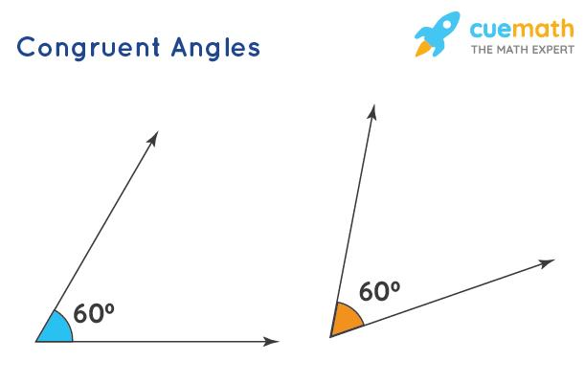
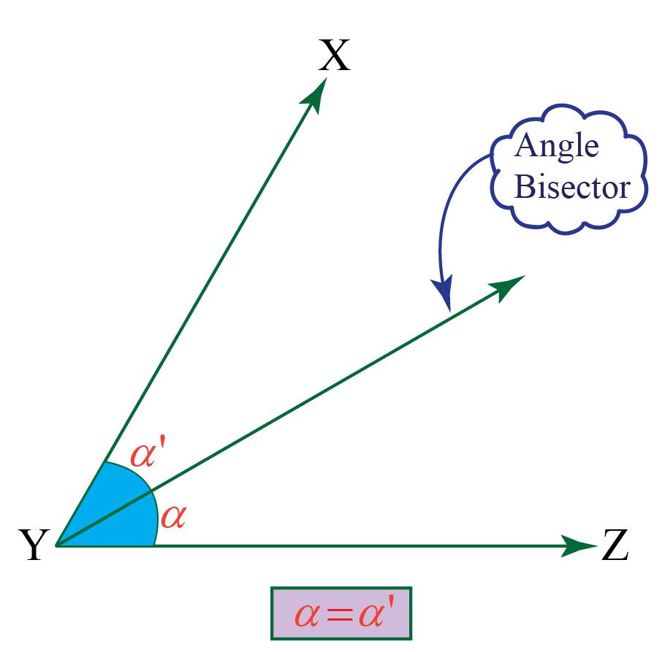
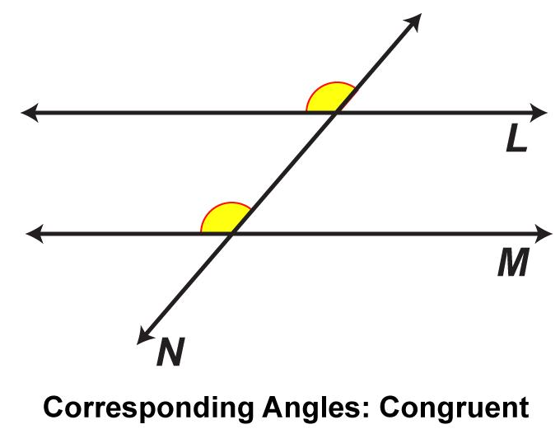
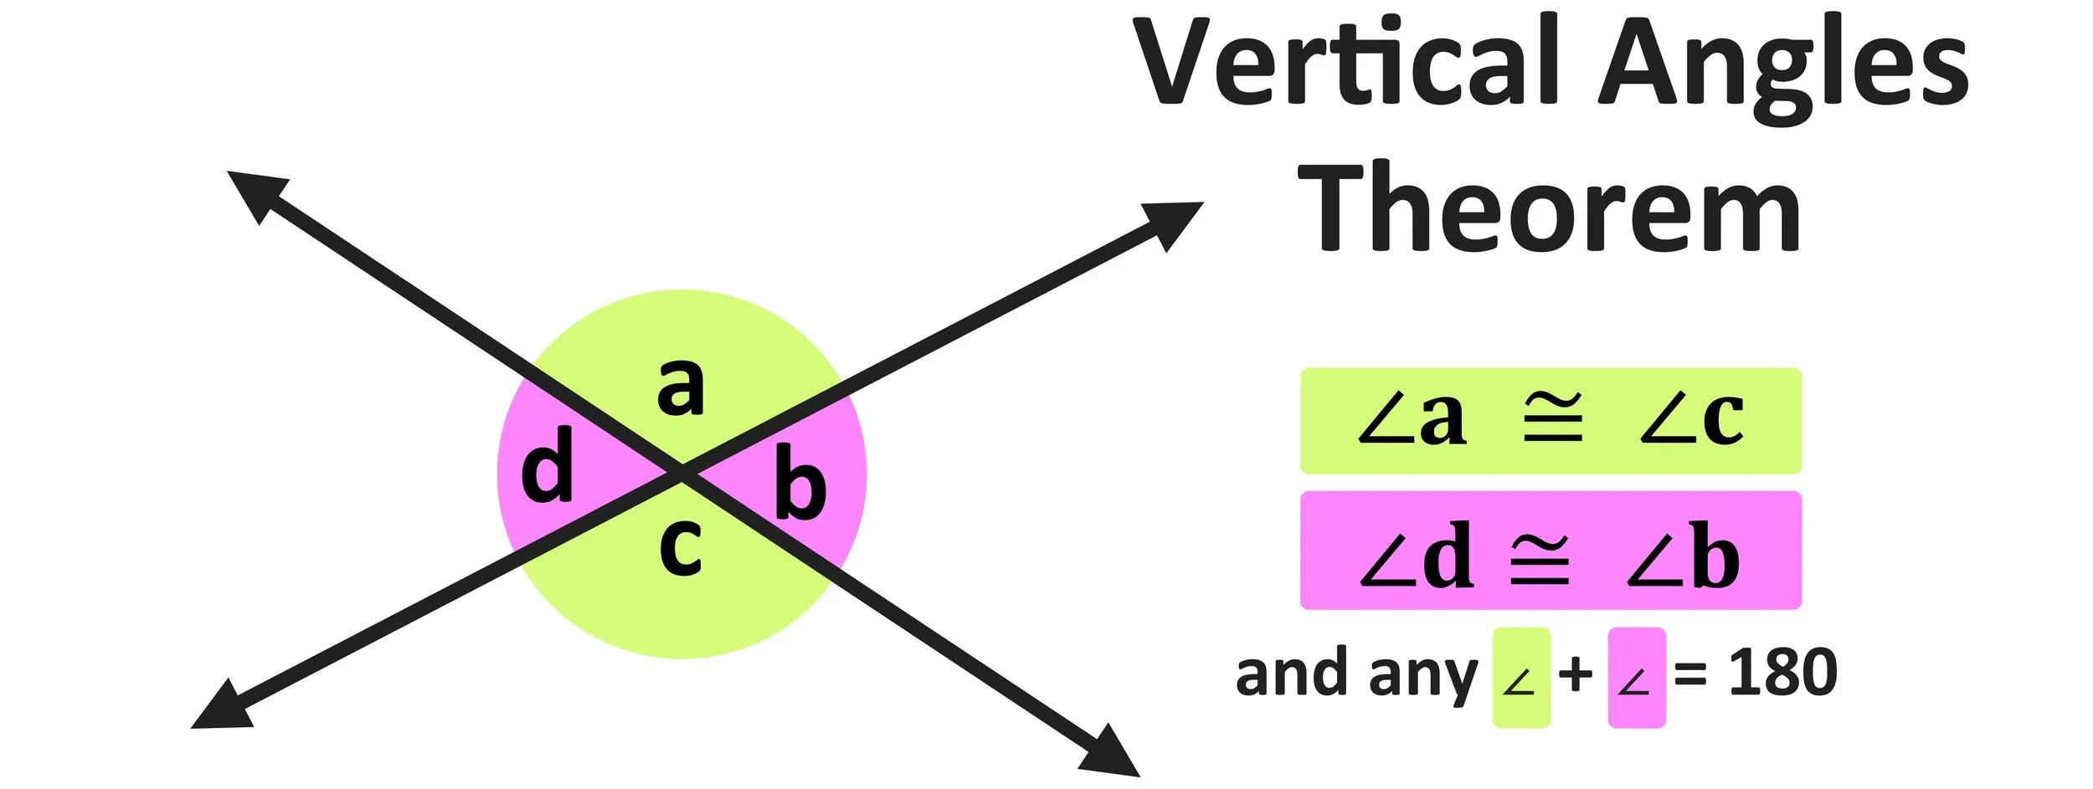
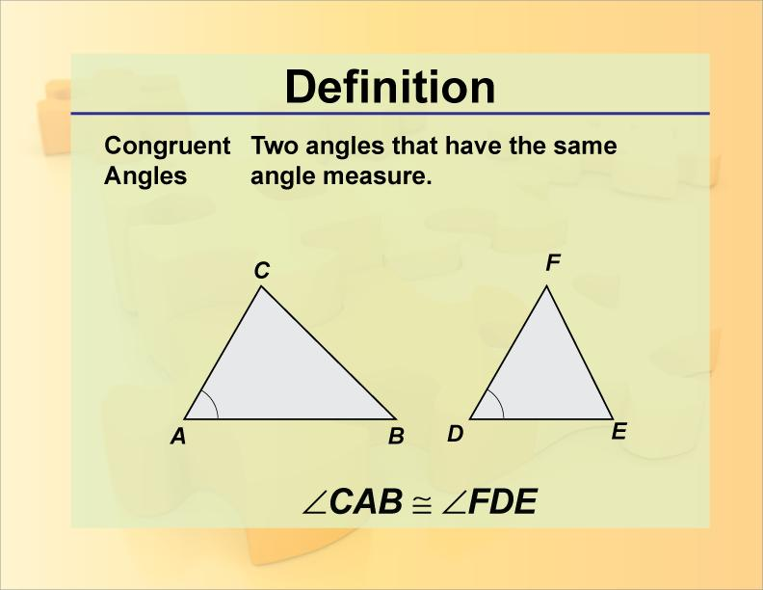
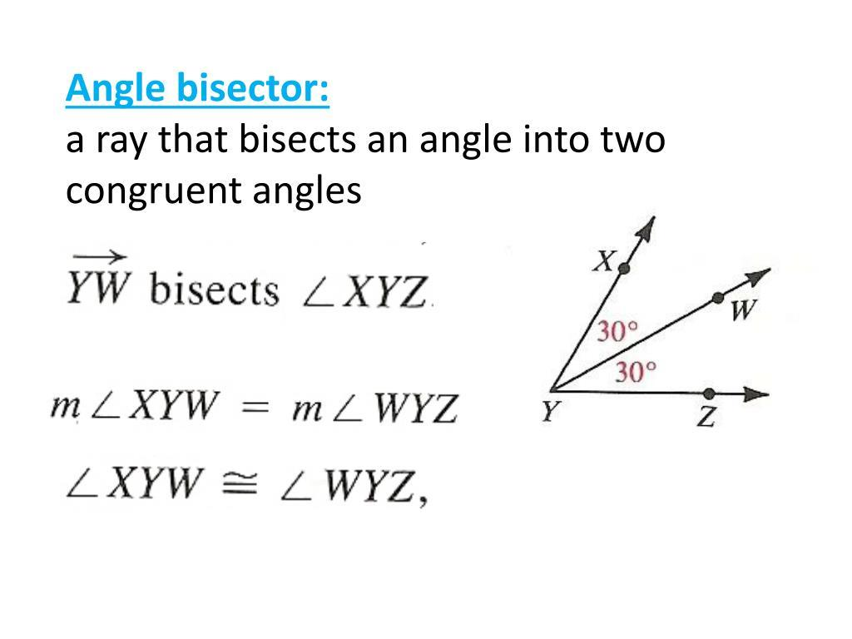
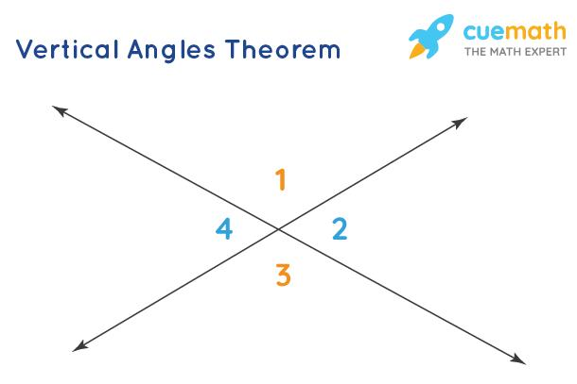

Definition
# Source: AI Source: Provided by: [Data Path: Persons Table -> ID Column: 1, Name_En Column: Motasem Essam] -> From: [ChatGPT] on [7/25/2026]
Angle Equality is an exact geometric relationship in which two or more angles have the same measure.
It is represented by:
$$\boxed{m∠A=m∠B}$$
For example:
$$m∠A={60}^{∘}, m∠B={60}^{∘}$$
Therefore:
$$\boxed{m∠A=m∠B}$$
The angles do not need to be in the same location or have the same orientation. Their measures are equal.

Simple Definition
# Source: AI Source: Provided by: [Data Path: Persons Table -> ID Column: 1, Name_En Column: Motasem Essam] -> From: [ChatGPT] on [7/25/2026]
Angle Equality means that two or more angles have exactly the same measure.
Example:
$$\boxed{m∠ABC=m∠DEF={45}^{∘}}$$

Fundamental Concept
# Source: AI Source: Provided by: [Data Path: Persons Table -> ID Column: 1, Name_En Column: Motasem Essam] -> From: [ChatGPT] on [7/25/2026]
Angle equality compares the measure of angles.
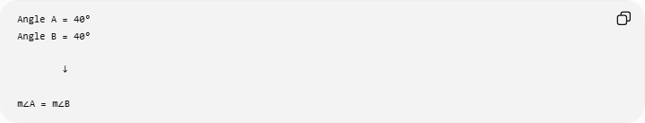
Angle A = 40°
Angle B = 40°

↓

m∠A = m∠B
The angles may:
- have different vertices,
- be in different figures,
- point in different directions,
- be located far apart.
What matters is:
$$\boxed{\text{Same angle measure}}$$

Types of Angle Equality
# Source: AI Source: Provided by: [Data Path: Persons Table -> ID Column: 1, Name_En Column: Motasem Essam] -> From: [ChatGPT] on [7/25/2026]
The following is a practical classification of the common ways angle equality is established. It is not a single universally standardized classification.
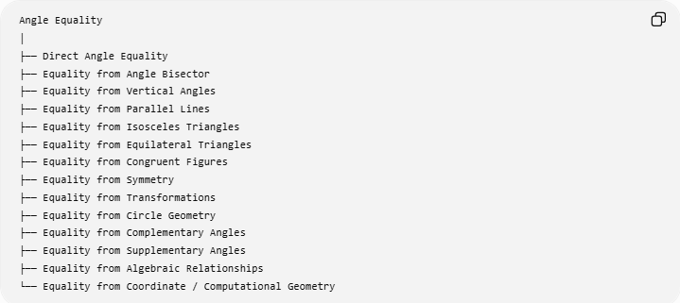
Angle Equality
│
├── Direct Angle Equality
├── Equality from Angle Bisector
├── Equality from Vertical Angles
├── Equality from Parallel Lines
├── Equality from Isosceles Triangles
├── Equality from Equilateral Triangles
├── Equality from Congruent Figures
├── Equality from Symmetry
├── Equality from Transformations
├── Equality from Circle Geometry
├── Equality from Complementary Angles
├── Equality from Supplementary Angles
├── Equality from Algebraic Relationships
└── Equality from Coordinate / Computational Geometry

Direct Angle Equality
# Source: AI Source: Provided by: [Data Path: Persons Table -> ID Column: 1, Name_En Column: Motasem Essam] -> From: [ChatGPT] on [7/25/2026]
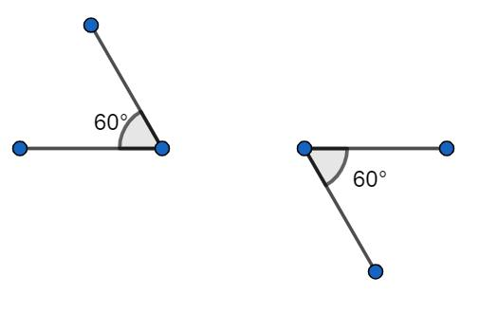
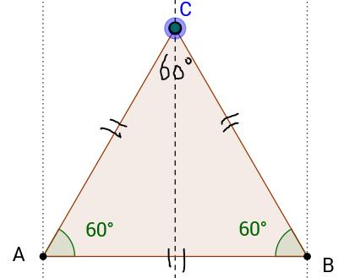
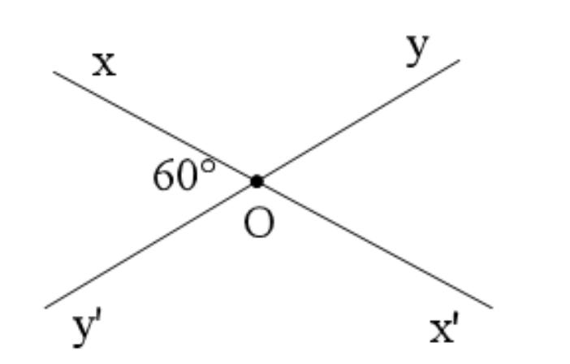
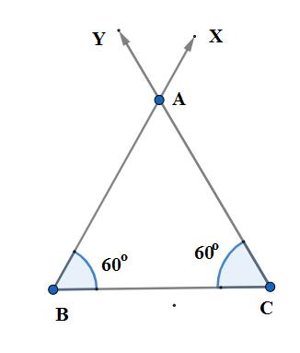
Definition
Angle equality may be given directly as known information:
$$\boxed{m∠A=m∠B}$$
Example
Given:
$$m∠ABC={70}^{∘}$$
and:
$$m∠DEF={70}^{∘}$$
Therefore:
$$\boxed{m∠ABC=m∠DEF}$$
Key Idea
The equality is already known; no theorem is needed to establish it.

Equality from an Angle Bisector
# Source: AI Source: Provided by: [Data Path: Persons Table -> ID Column: 1, Name_En Column: Motasem Essam] -> From: [ChatGPT] on [7/25/2026]
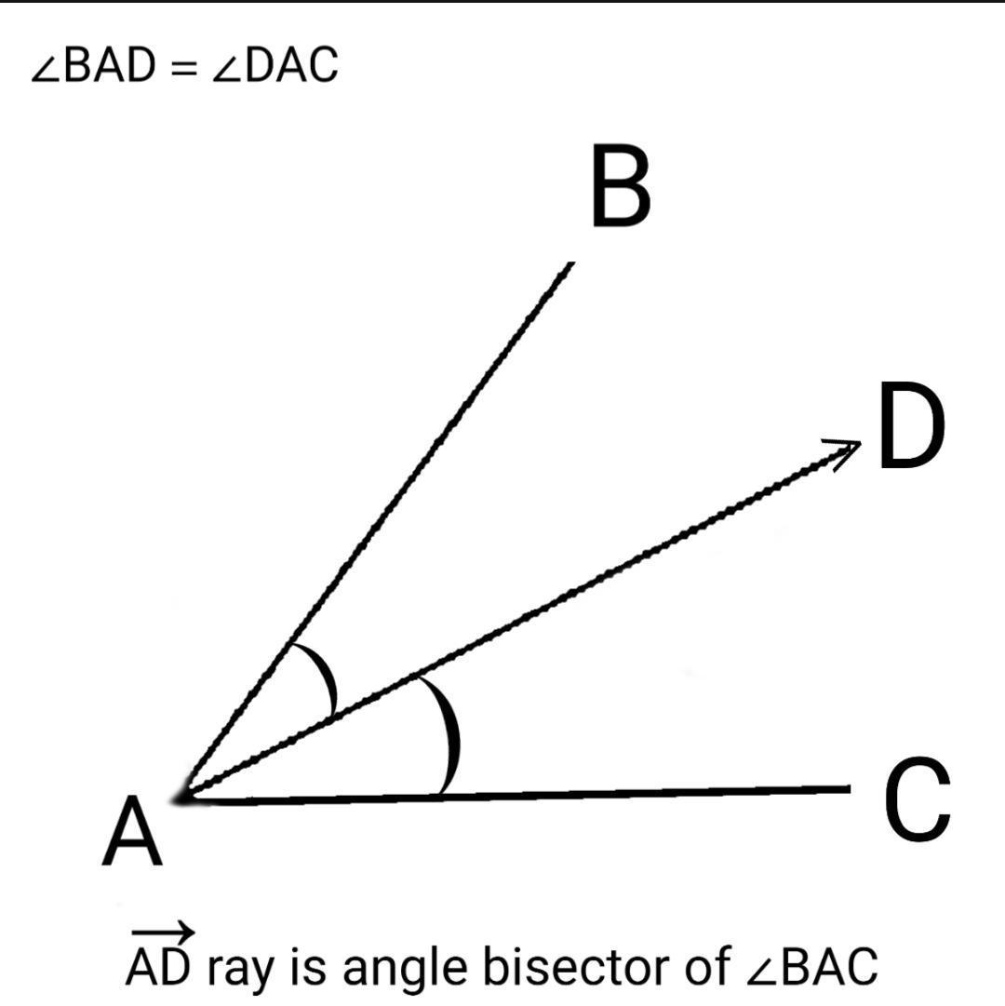
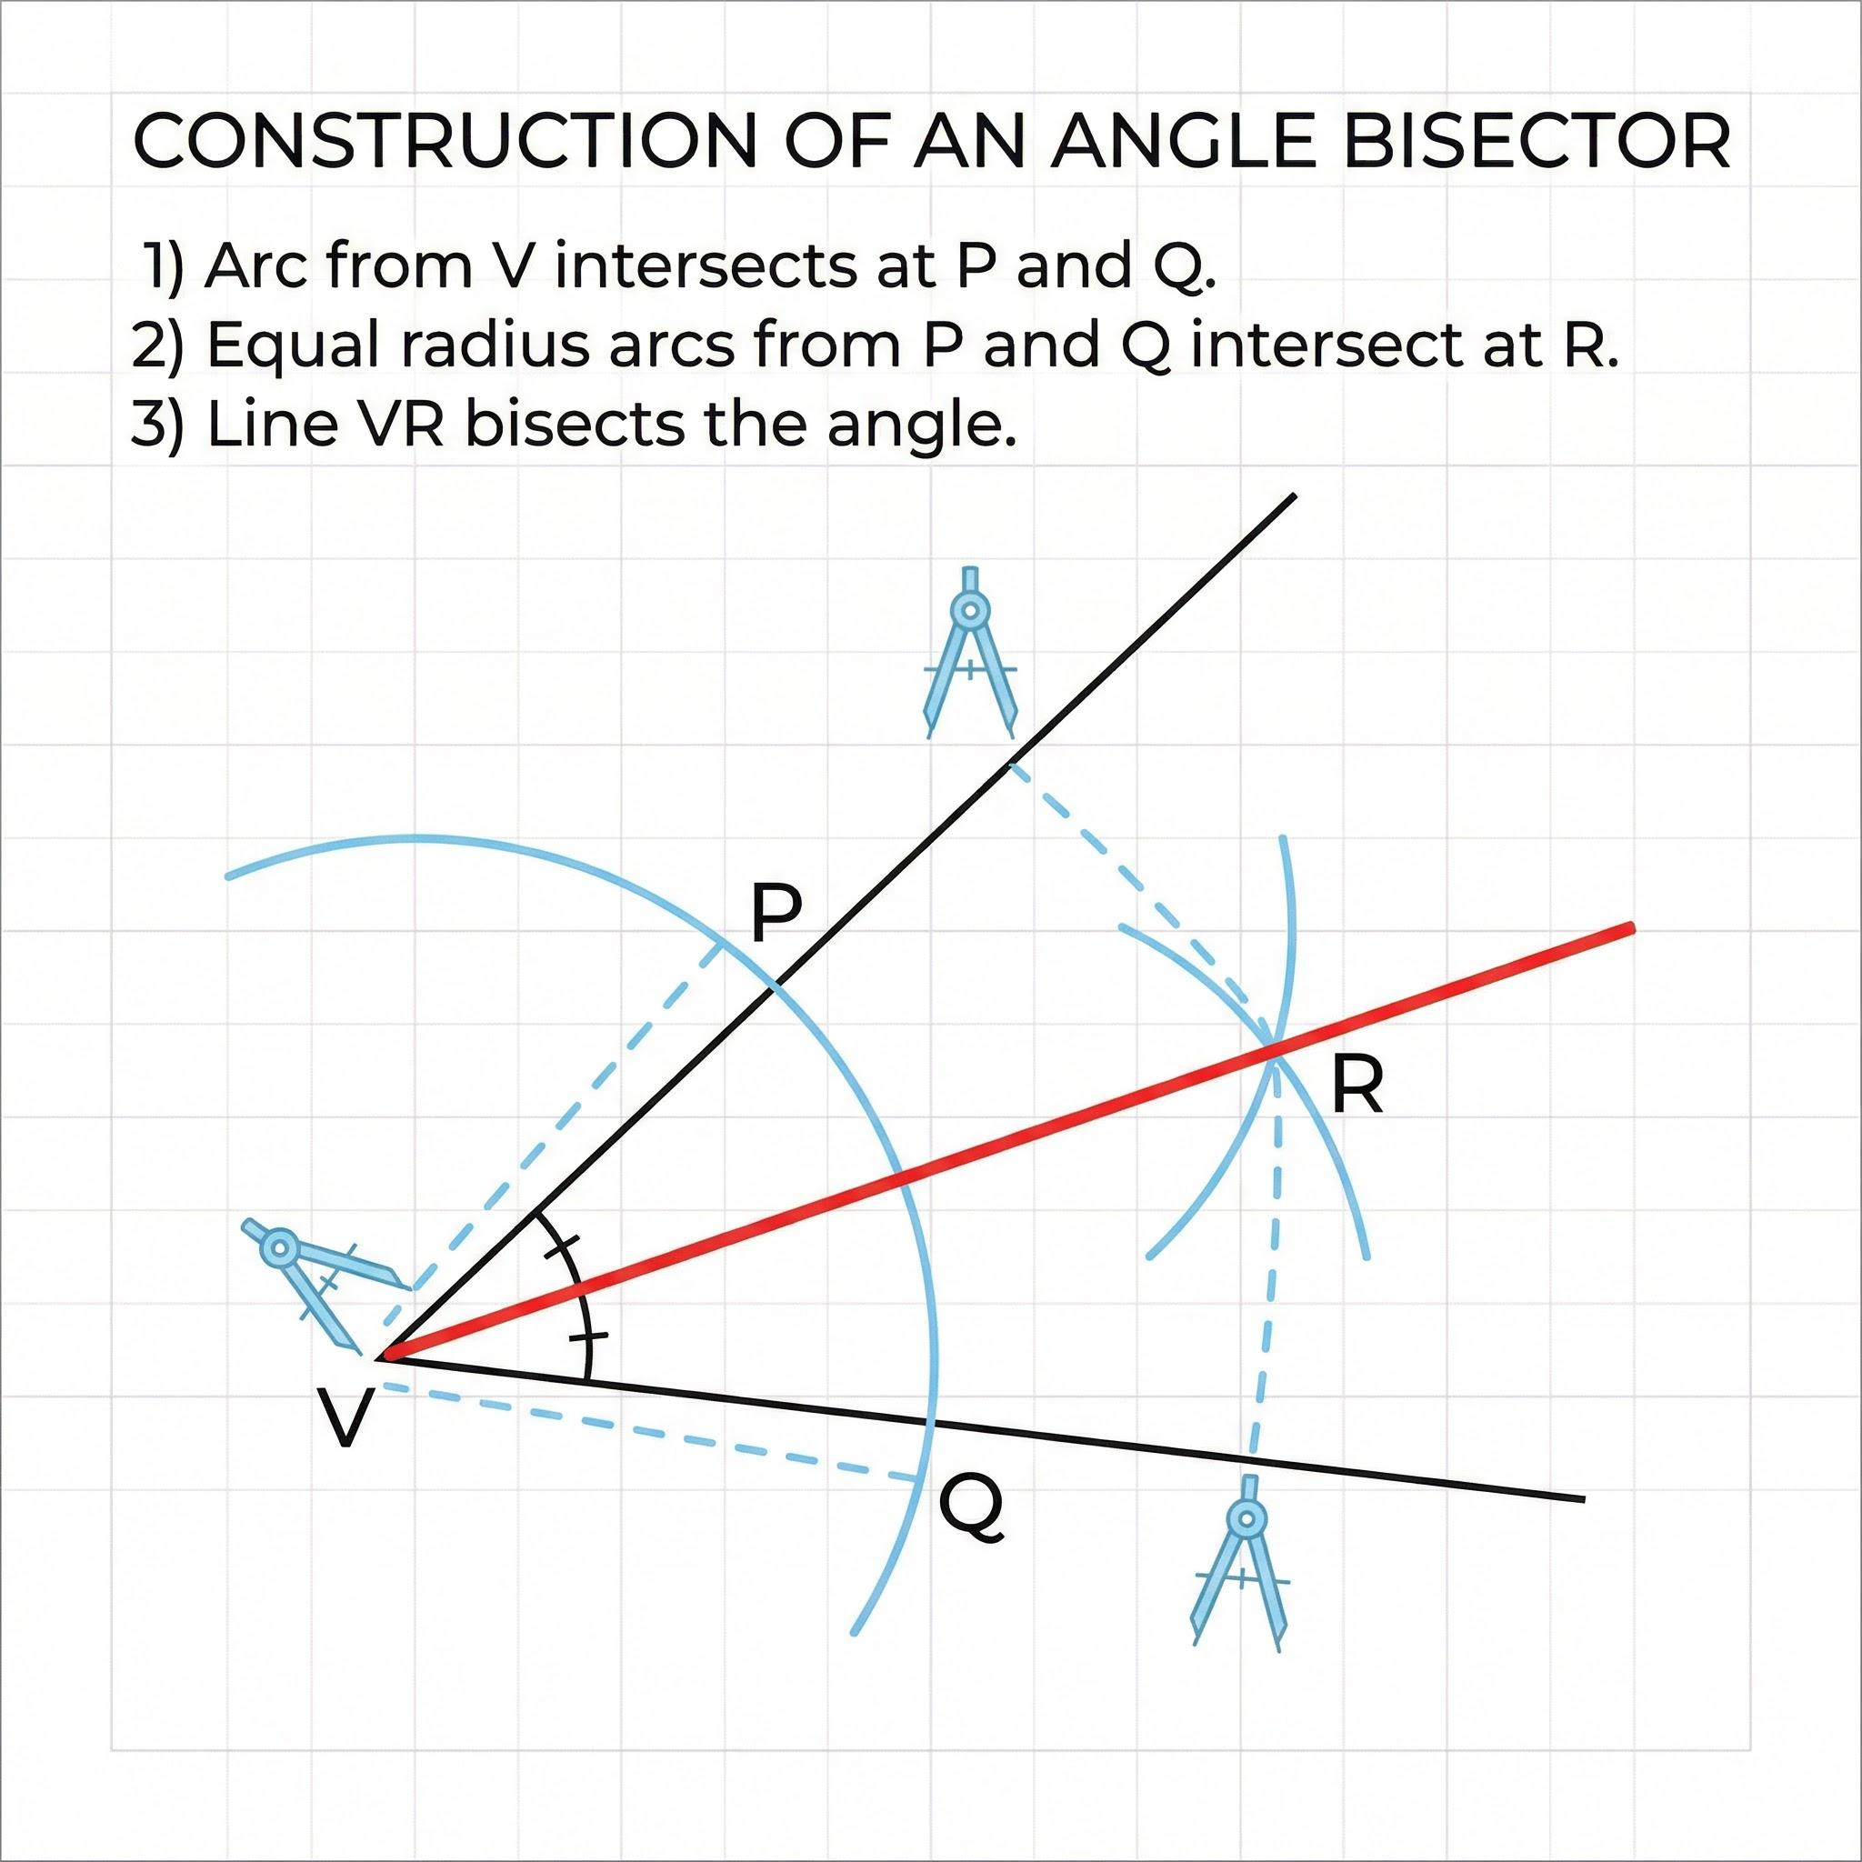
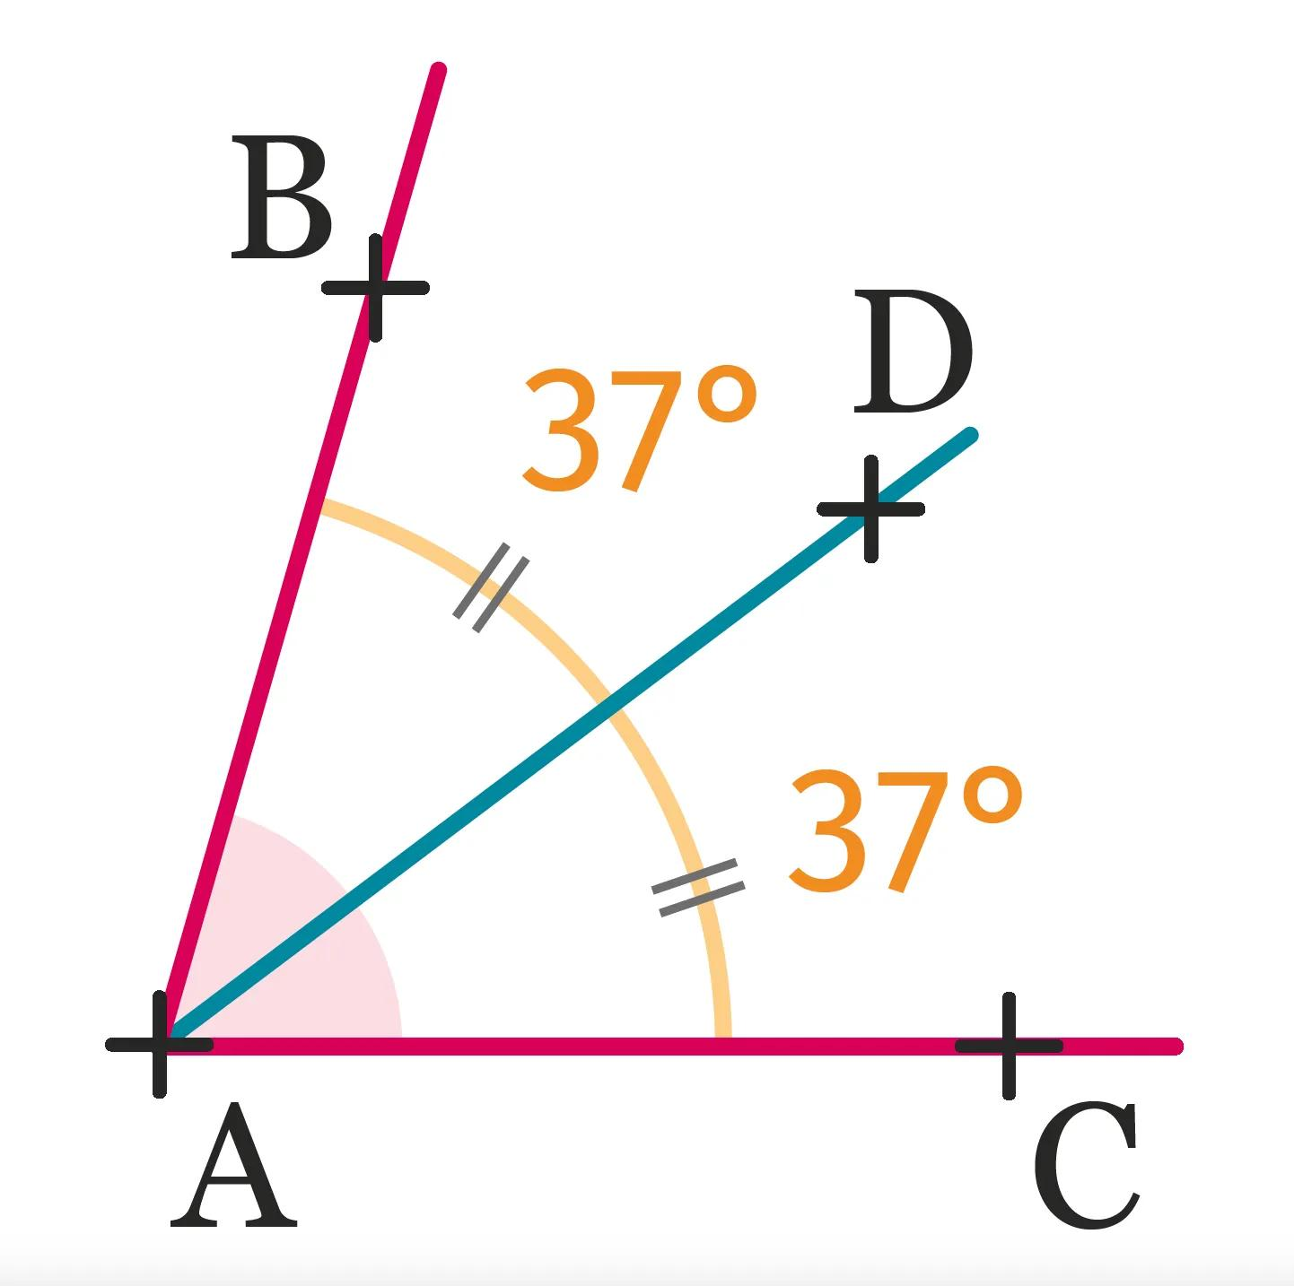
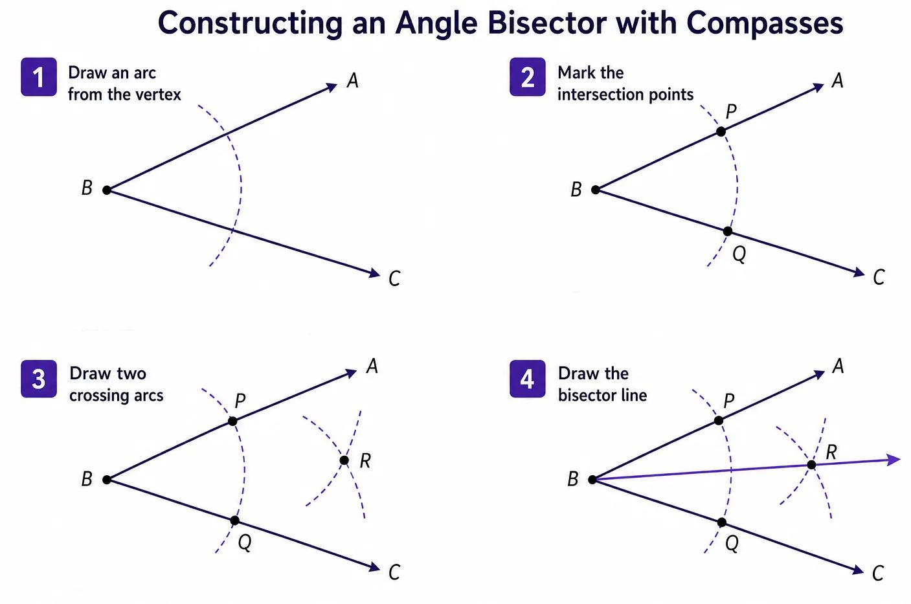
Definition
An angle bisector divides an angle into two equal angles.
If $BD$bisects $∠ABC$, then:
$$\boxed{m∠ABD=m∠DBC}$$
Example
If:
$$m∠ABC={80}^{∘}$$
then the angle bisector divides it into:
$$m∠ABD={40}^{∘}$$
and:
$$m∠DBC={40}^{∘}$$
Therefore:
$$\boxed{m∠ABD=m∠DBC={40}^{∘}}$$
Key Relationship
$$\boxed{\text{Angle Bisector}→\text{Equal Angles}}$$

Equality from Vertical Angles
# Source: AI Source: Provided by: [Data Path: Persons Table -> ID Column: 1, Name_En Column: Motasem Essam] -> From: [ChatGPT] on [7/25/2026]
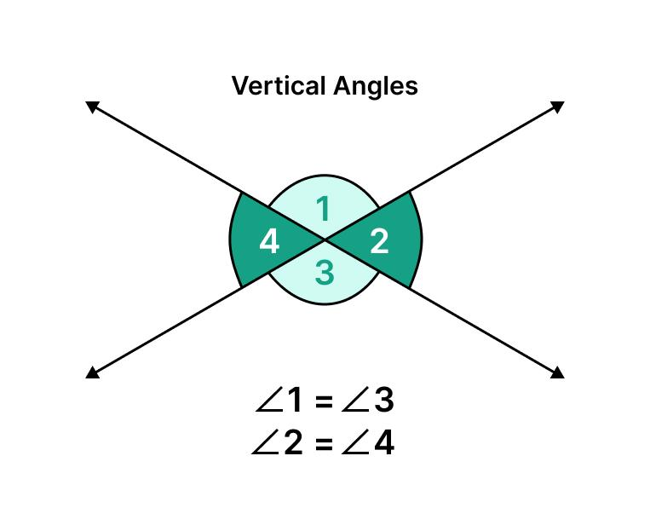
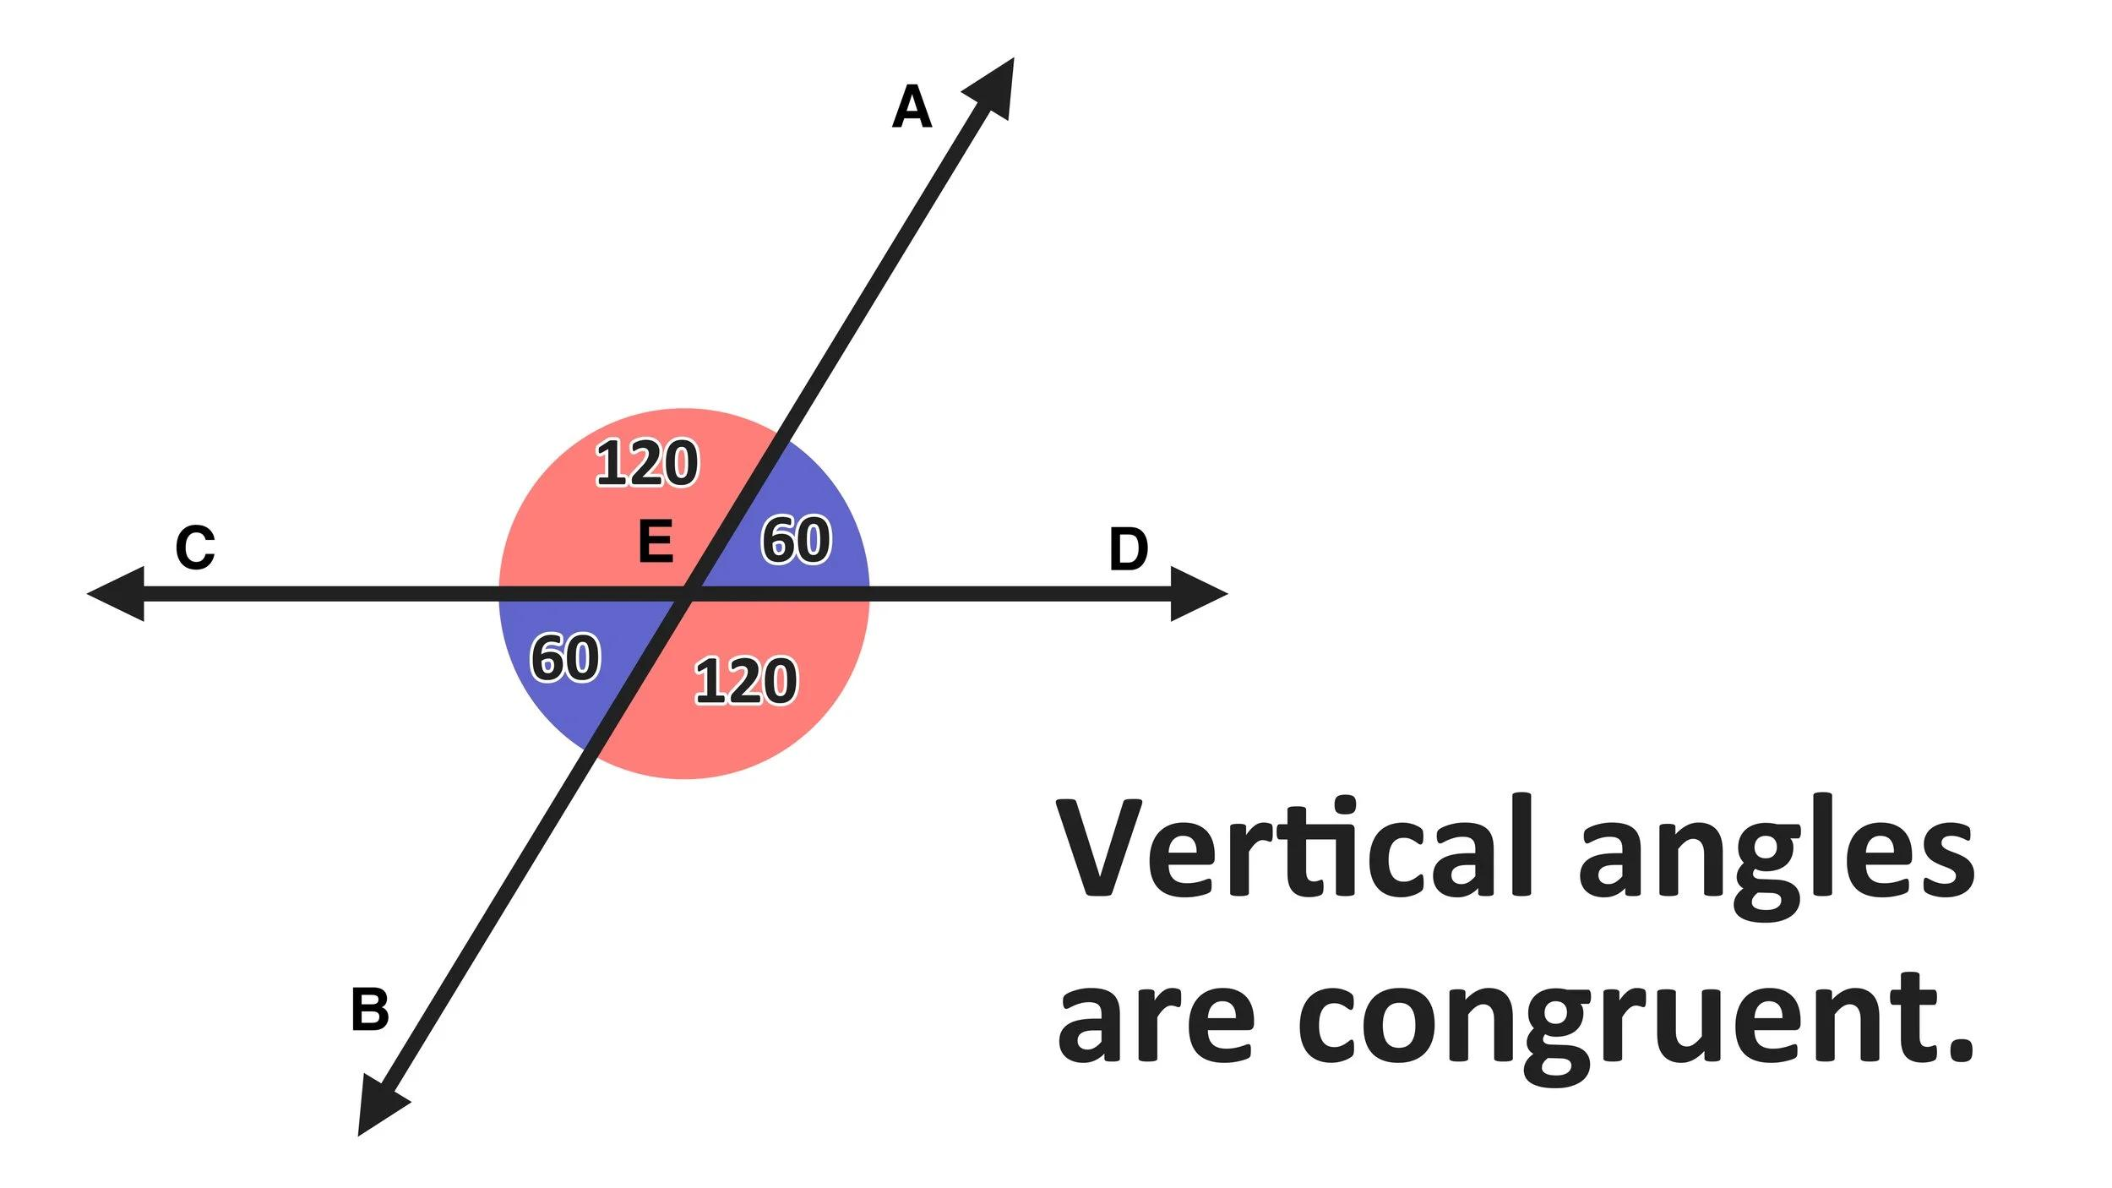
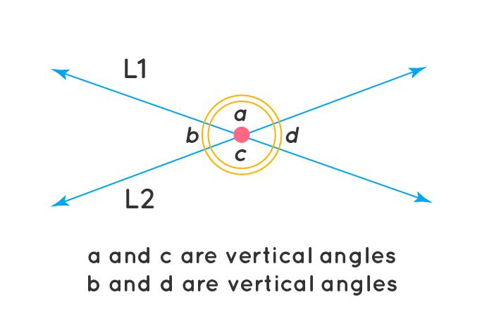
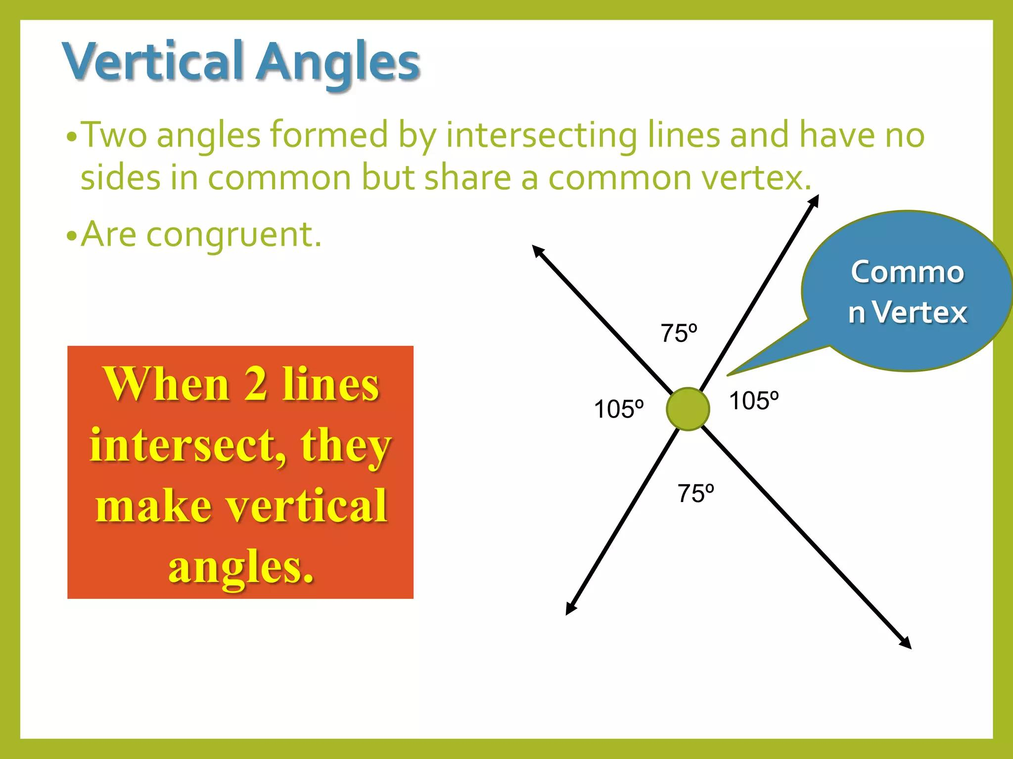
Definition
When two lines intersect, the opposite angles are called vertical angles.
Vertical angles are always equal.
If two lines intersect at $O$:
$$\boxed{m∠AOC=m∠BOD}$$
and:
$$\boxed{m∠AOD=m∠BOC}$$
Example
If:
$$m∠AOC={65}^{∘}$$
then:
$$\boxed{m∠BOD={65}^{∘}}$$
because they are vertical angles.

Equality from Parallel Lines
# Source: AI Source: Provided by: [Data Path: Persons Table -> ID Column: 1, Name_En Column: Motasem Essam] -> From: [ChatGPT] on [7/25/2026]
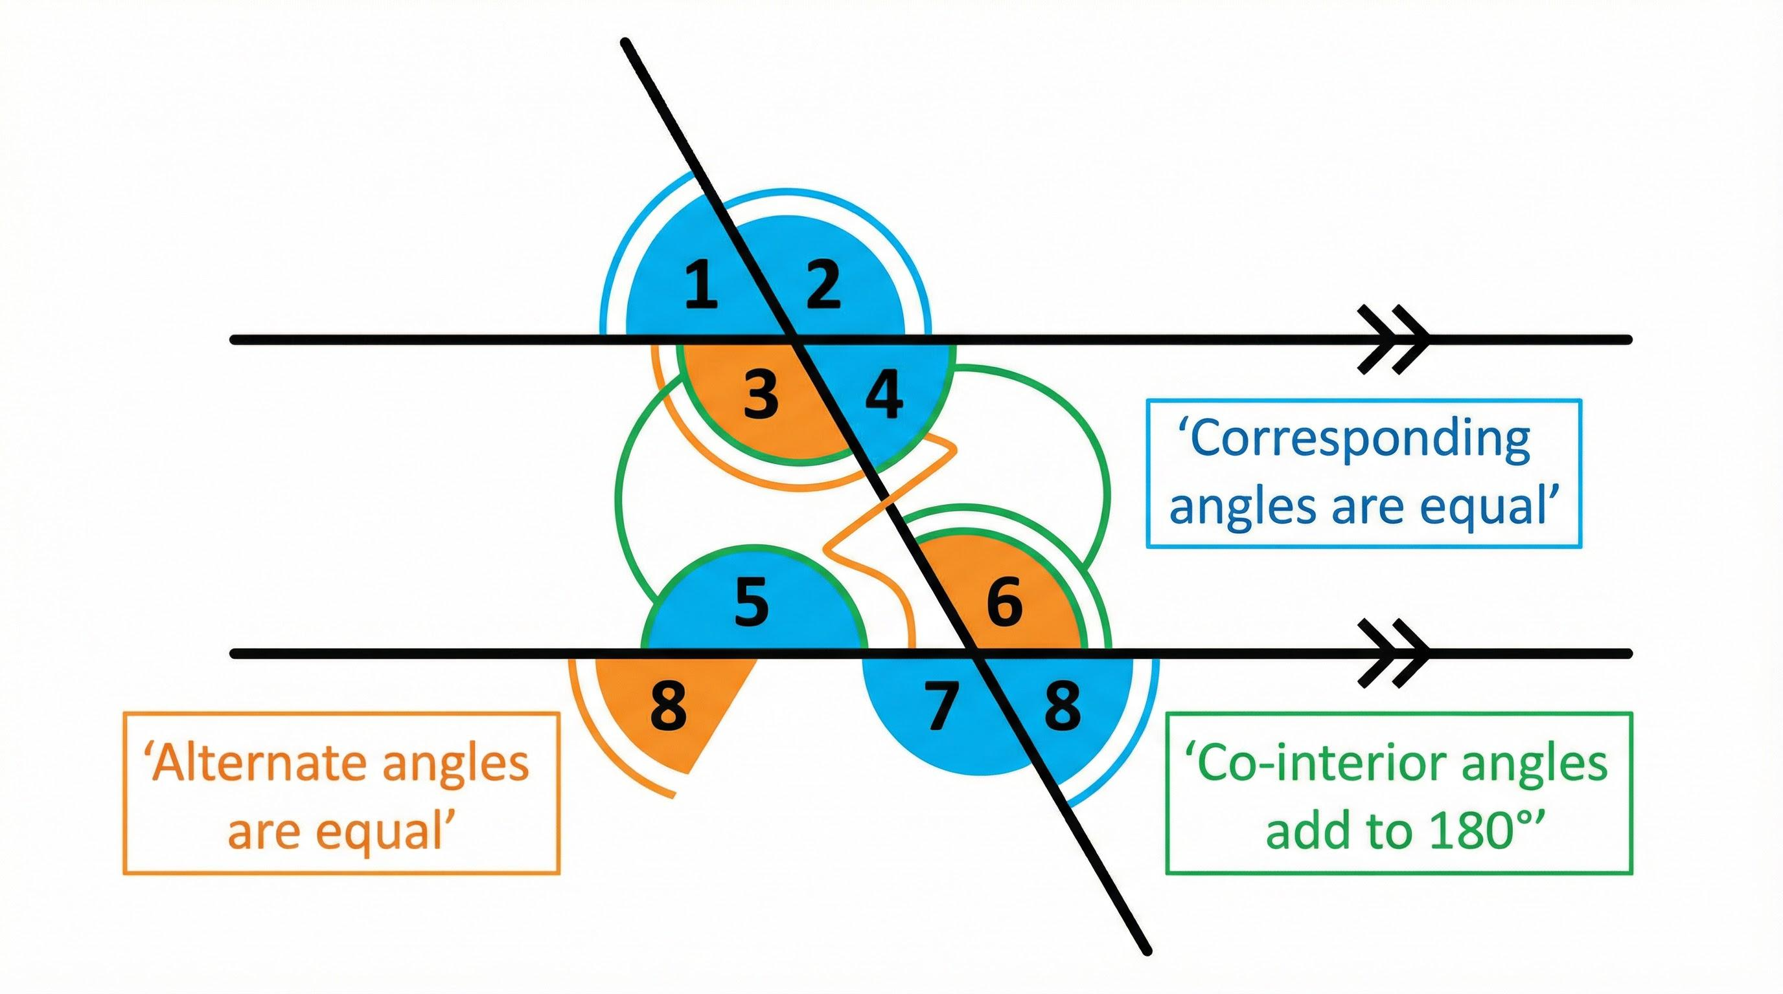
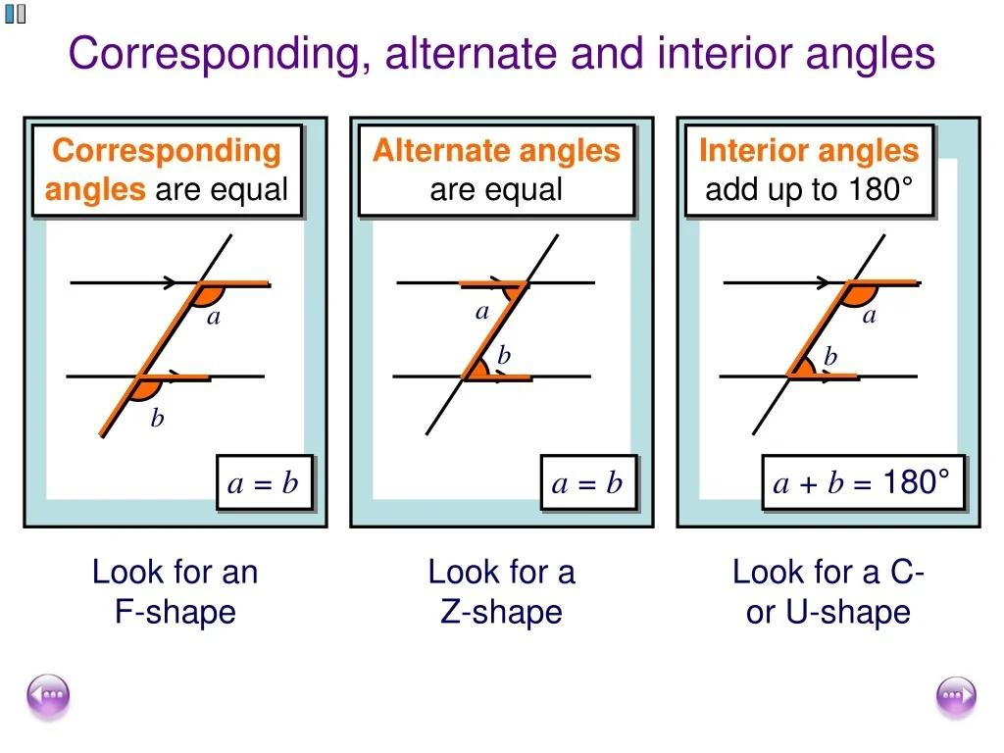
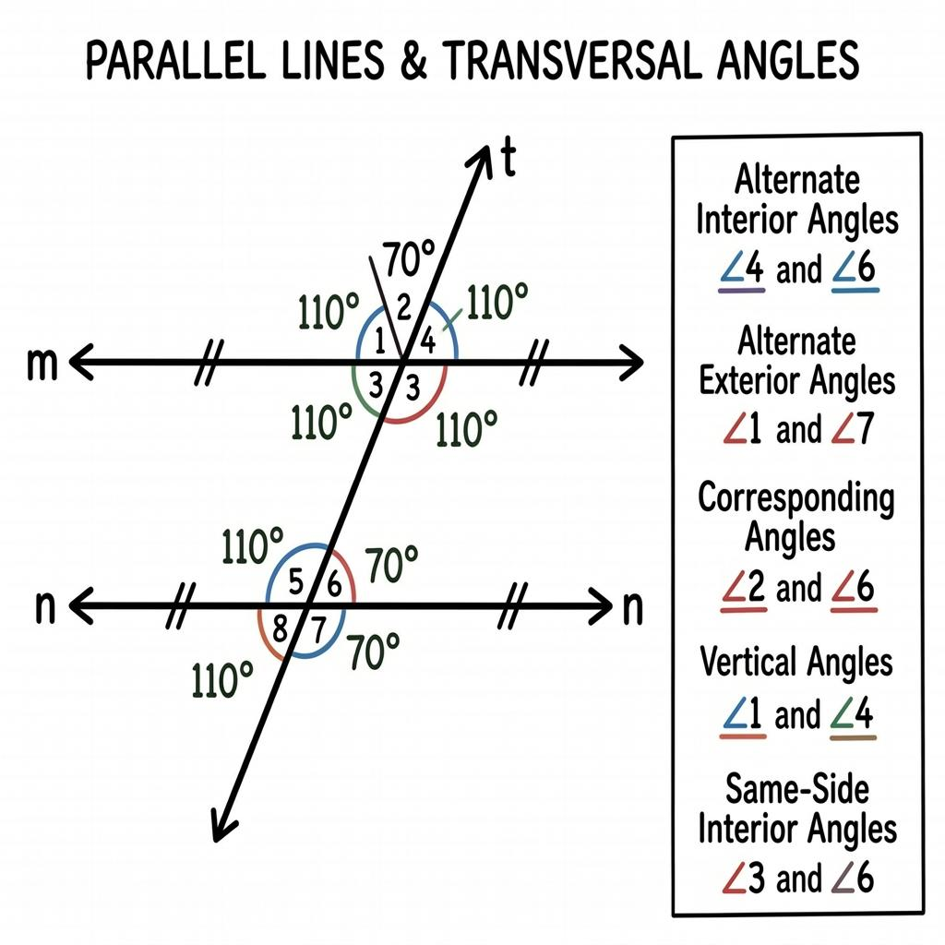
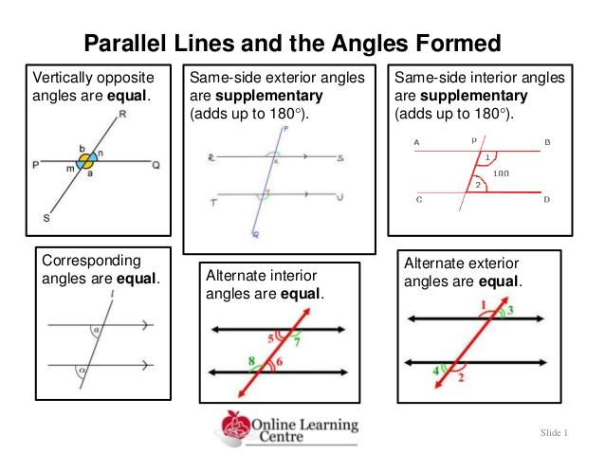
When a transversal intersects two parallel lines, several pairs of angles are equal.
Assume:
$$l_{1}∥l_{2}$$

1-Corresponding Angles
# Source: AI Source: Provided by: [Data Path: Persons Table -> ID Column: 1, Name_En Column: Motasem Essam] -> From: [ChatGPT] on [7/25/2026]
Corresponding angles are equal:
$$\boxed{m∠1=m∠2}$$
Example
If one corresponding angle is:
$${70}^{∘}$$
the other is:
$${70}^{∘}$$

2-Alternate Interior Angles
# Source: AI Source: Provided by: [Data Path: Persons Table -> ID Column: 1, Name_En Column: Motasem Essam] -> From: [ChatGPT] on [7/25/2026]
Alternate interior angles are equal when the lines are parallel:
$$\boxed{m∠A=m∠B}$$
Example
$$m∠A={55}^{∘}$$
Therefore:
$$\boxed{m∠B={55}^{∘}}$$

3-Alternate Exterior Angles
# Source: AI Source: Provided by: [Data Path: Persons Table -> ID Column: 1, Name_En Column: Motasem Essam] -> From: [ChatGPT] on [7/25/2026]
Alternate exterior angles are also equal:
$$\boxed{m∠A=m∠B}$$
when the two lines are parallel.

Equality from Isosceles Triangles
# Source: AI Source: Provided by: [Data Path: Persons Table -> ID Column: 1, Name_En Column: Motasem Essam] -> From: [ChatGPT] on [7/25/2026]
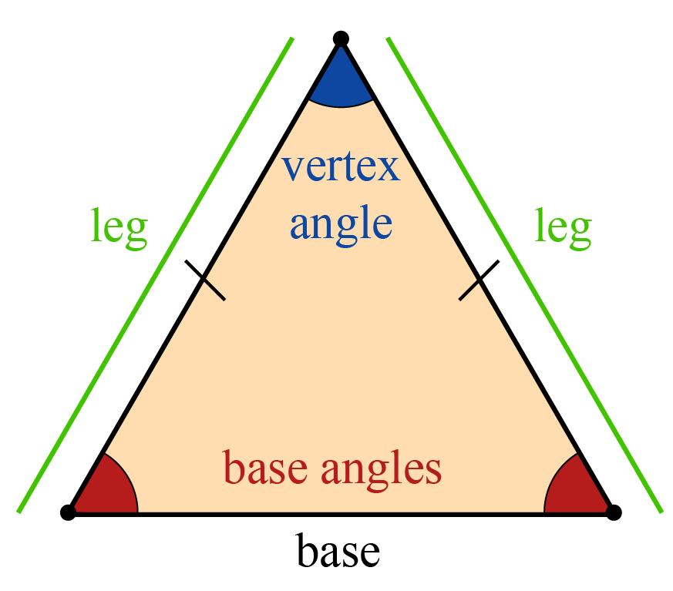
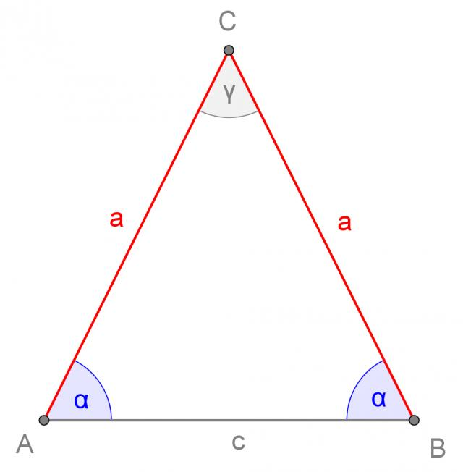
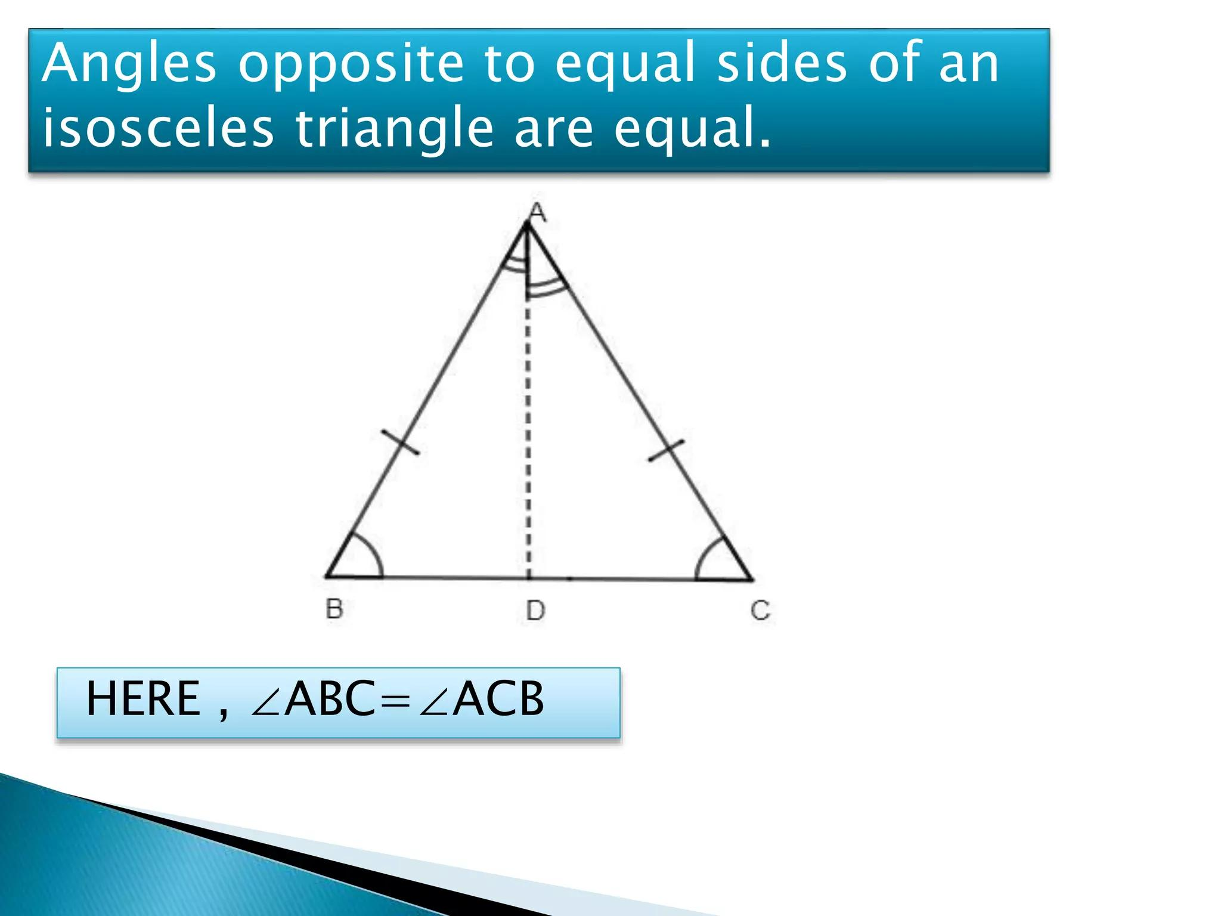
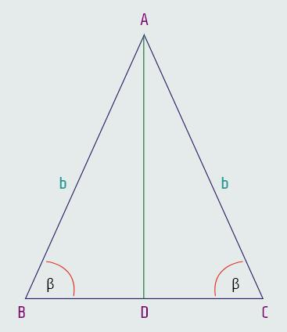
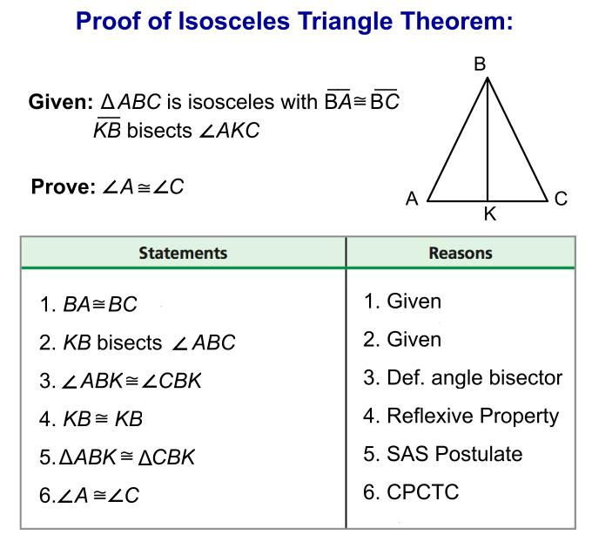
Definition
An isosceles triangle has at least two equal sides.
If:
$$AB=AC$$
then the opposite base angles are equal:
$$\boxed{m∠ABC=m∠BCA}$$
Example
Suppose:
$$AB=AC$$
and:
$$m∠B={50}^{∘}$$
Then:
$$\boxed{m∠C={50}^{∘}}$$
Since the triangle angle sum is ${180}^{∘}$:
$$m∠A={180}^{∘}-{50}^{∘}-{50}^{∘} \\ \boxed{m∠A={80}^{∘}}$$
Key Relationship
$$\boxed{\text{Equal Sides}→\text{Equal Opposite Angles}}$$

Equality from Equilateral Triangles
# Source: AI Source: Provided by: [Data Path: Persons Table -> ID Column: 1, Name_En Column: Motasem Essam] -> From: [ChatGPT] on [7/25/2026]
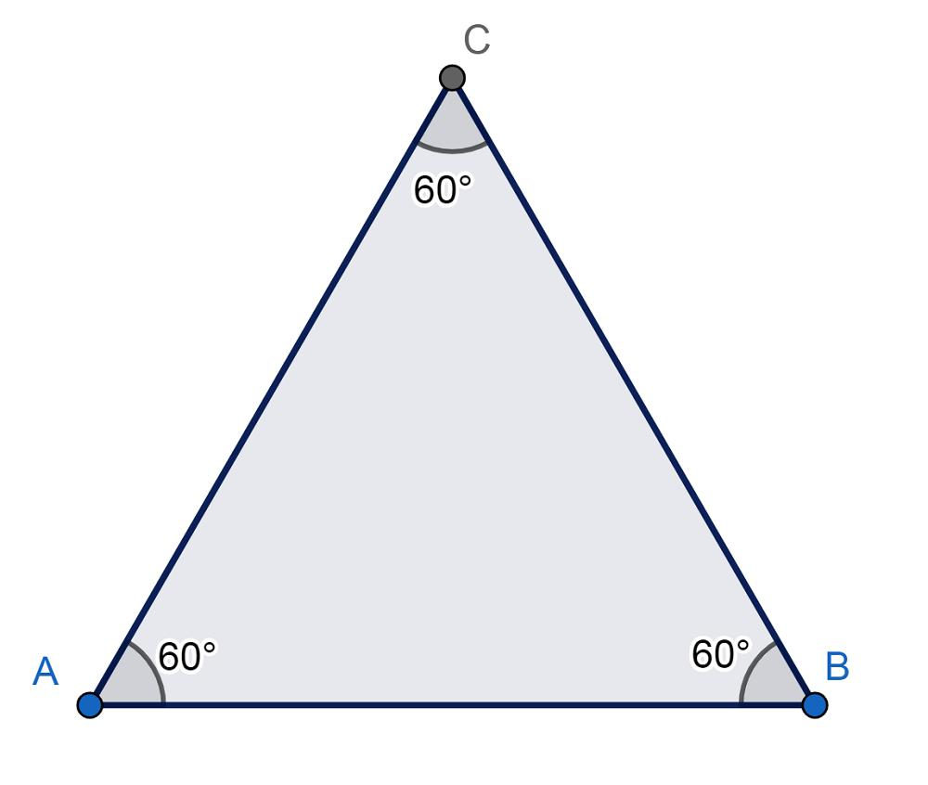
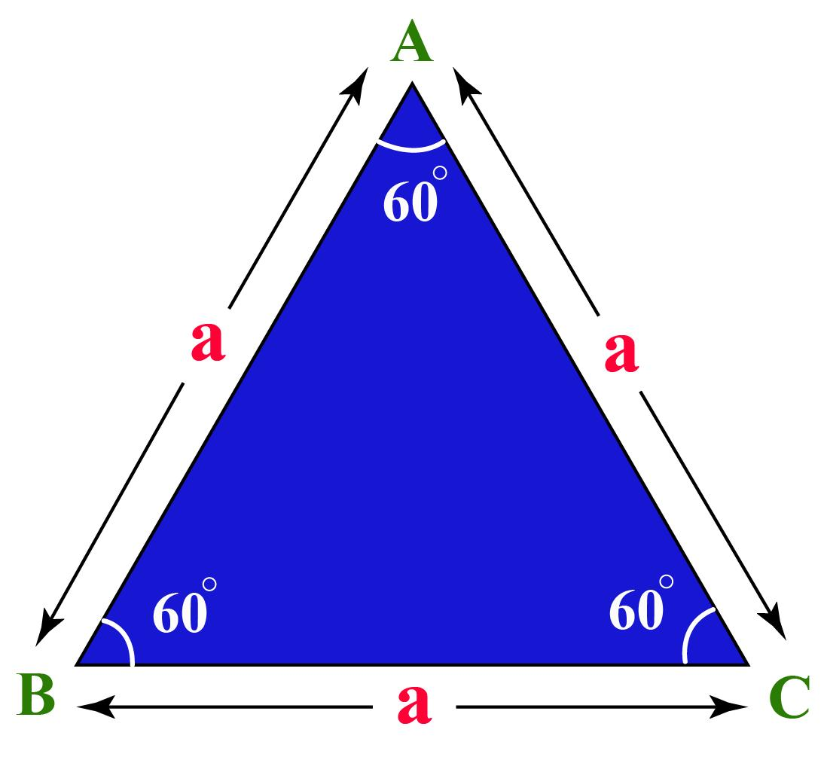
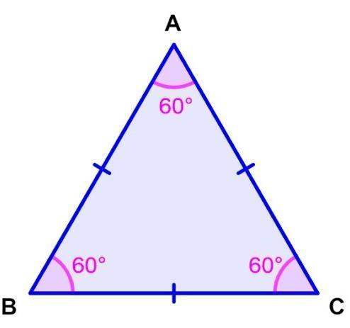
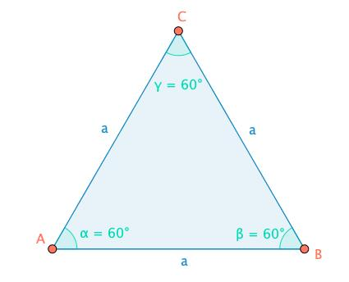
An equilateral triangle has three equal sides.
It also has three equal angles:
$$\boxed{m∠A=m∠B=m∠C}$$
Since the sum of the angles is ${180}^{∘}$:
$$3θ={180}^{∘} \\ \boxed{θ={60}^{∘}}$$
Therefore:
$$\boxed{m∠A=m∠B=m∠C={60}^{∘}}$$

Equality from Congruent Figures
# Source: AI Source: Provided by: [Data Path: Persons Table -> ID Column: 1, Name_En Column: Motasem Essam] -> From: [ChatGPT] on [7/25/2026]
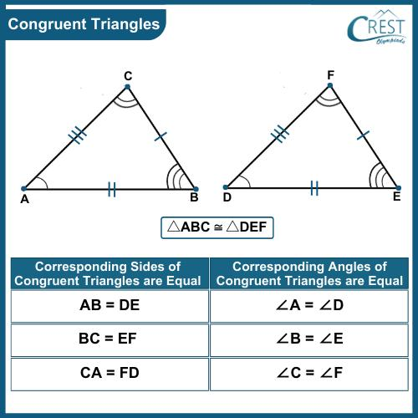
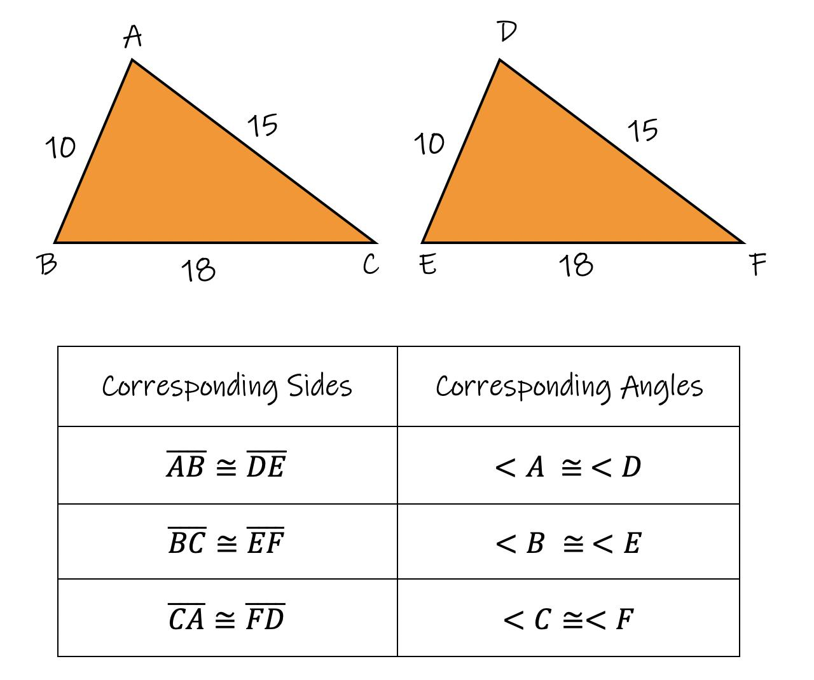
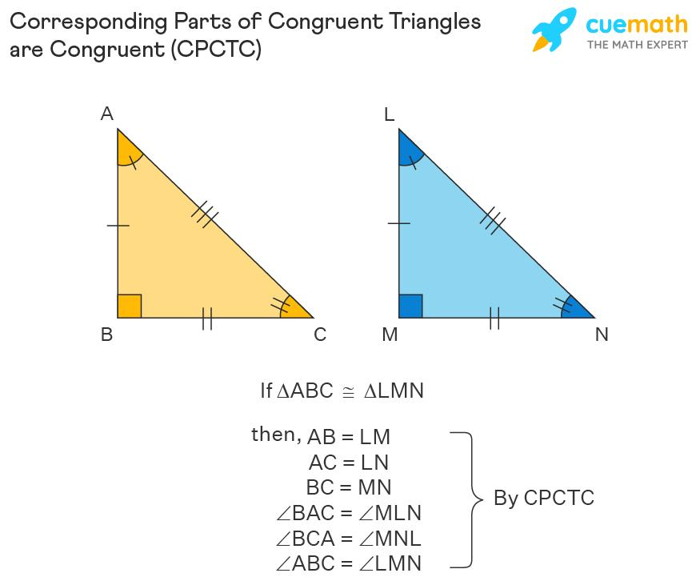
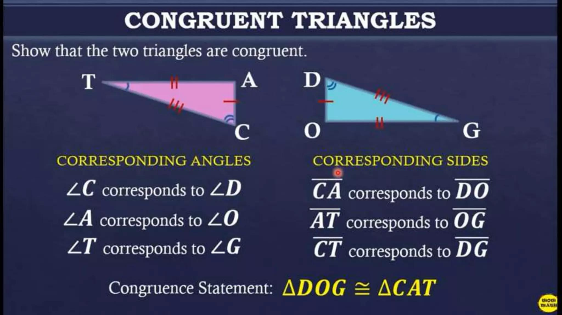
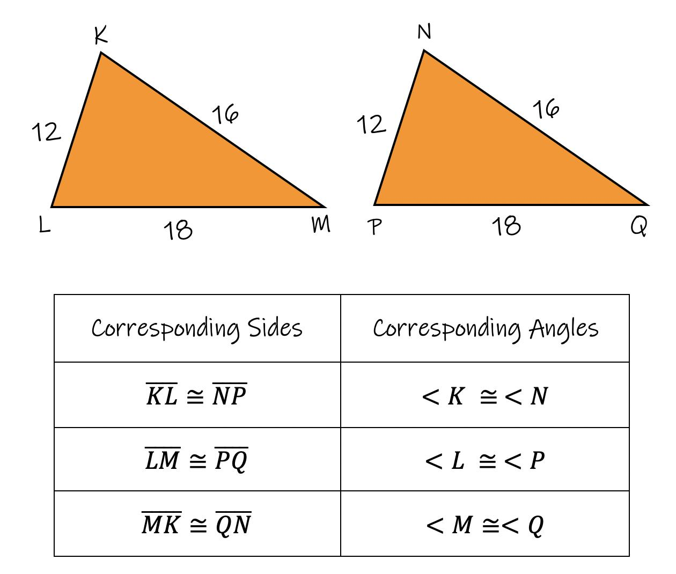
If two figures are congruent, their corresponding angles have equal measures.
For example:
$$△ABC≅△DEF$$
Then:
$$\boxed{m∠A=m∠D} \\ \boxed{m∠B=m∠E} \\ \boxed{m∠C=m∠F}$$
This is commonly justified by CPCTC:
Corresponding Parts of Congruent Triangles are Congruent.

Equality from Symmetry
# Source: AI Source: Provided by: [Data Path: Persons Table -> ID Column: 1, Name_En Column: Motasem Essam] -> From: [ChatGPT] on [7/25/2026]
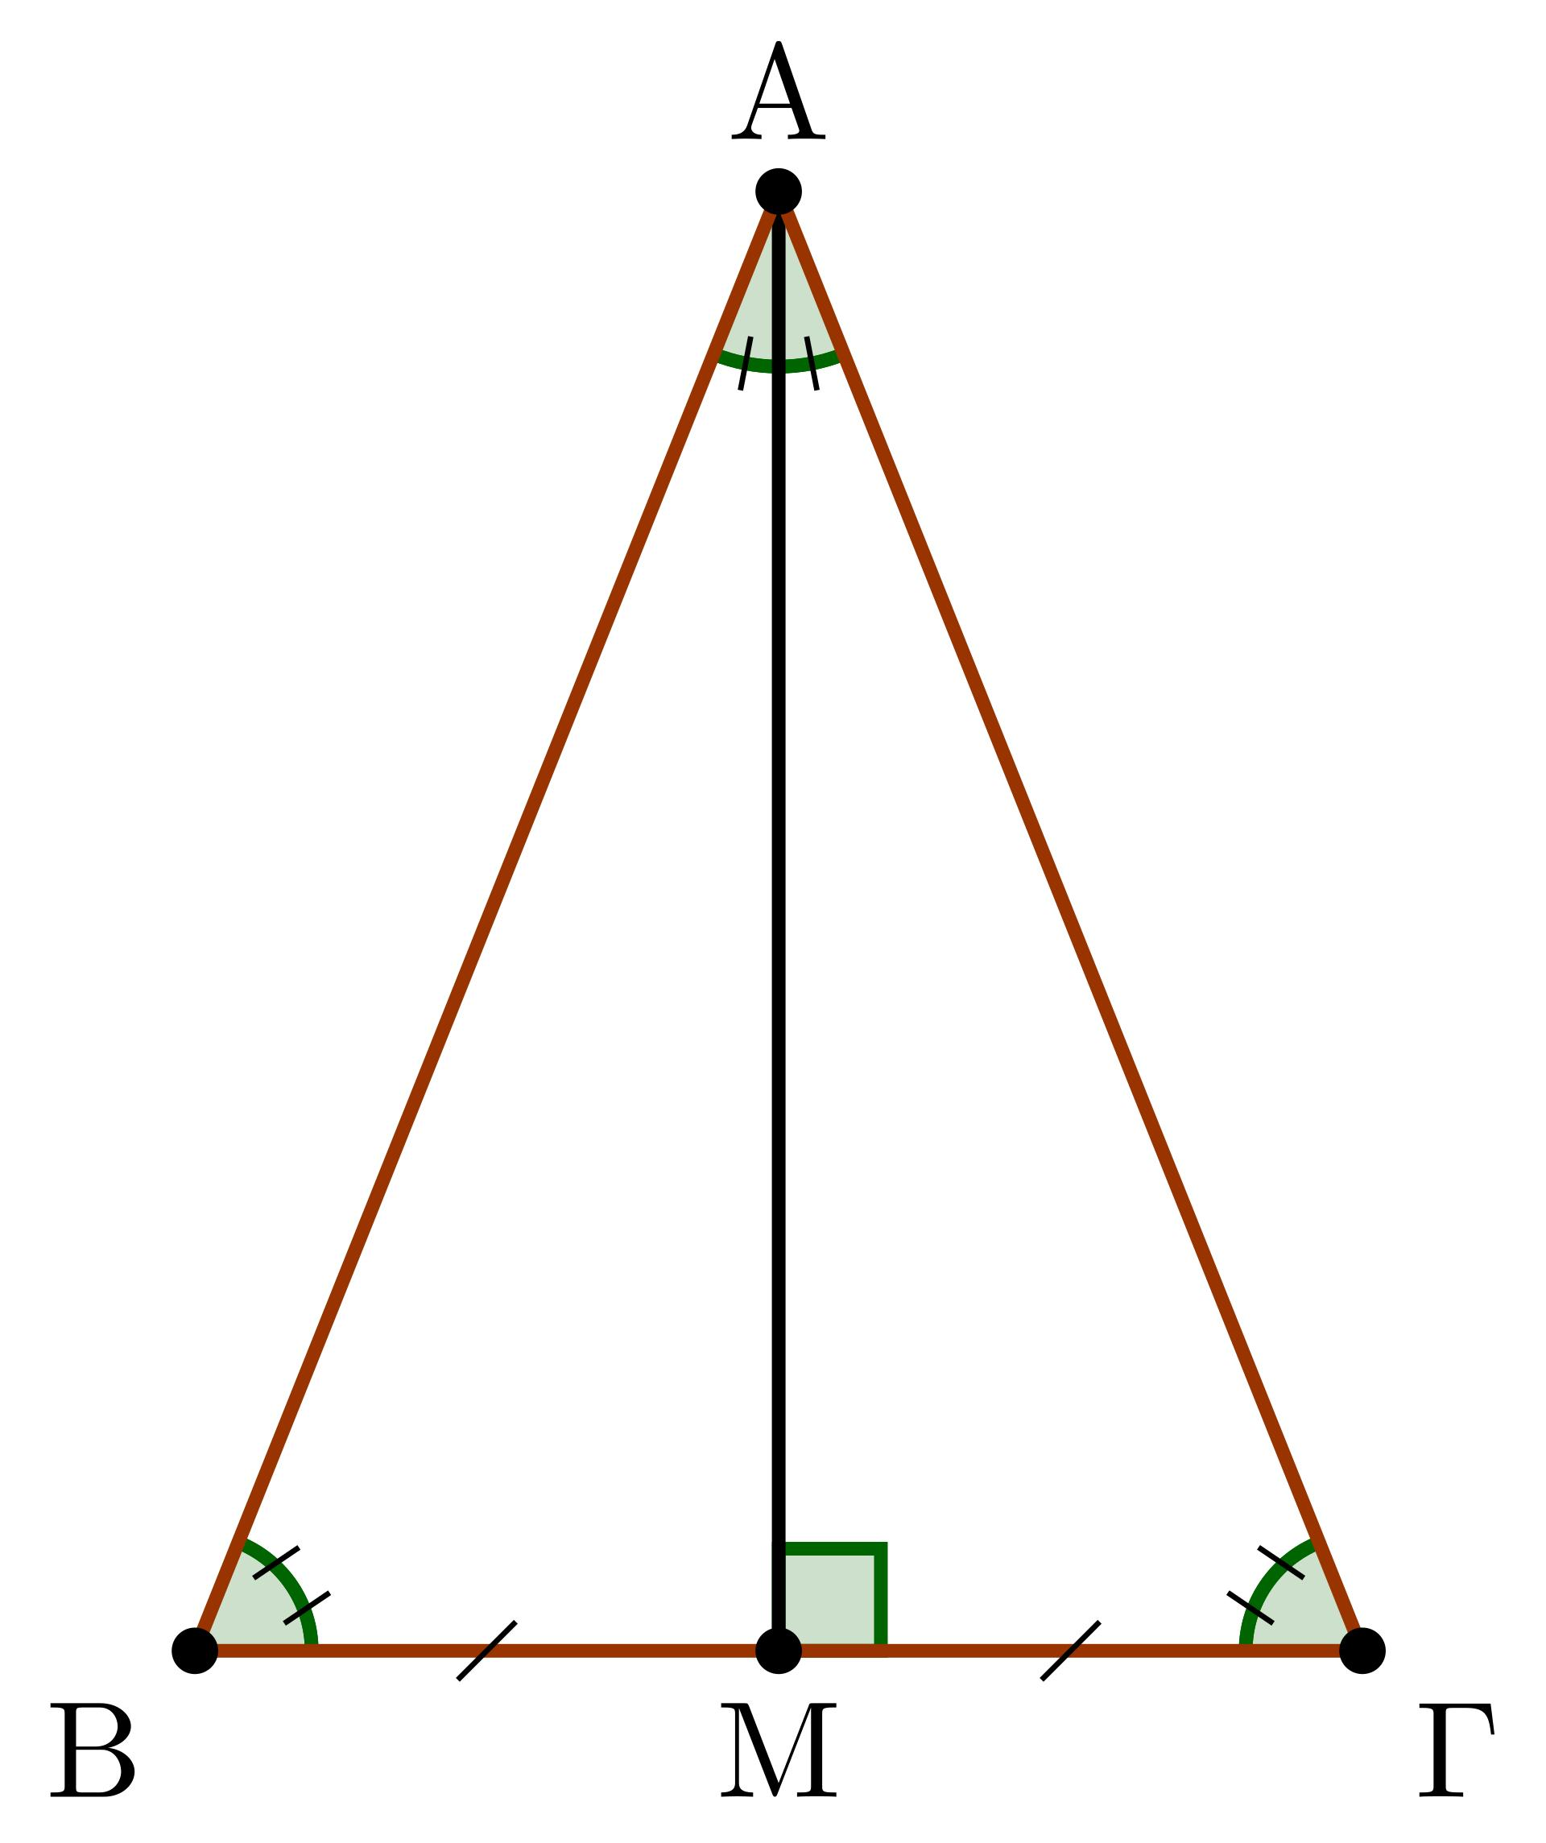
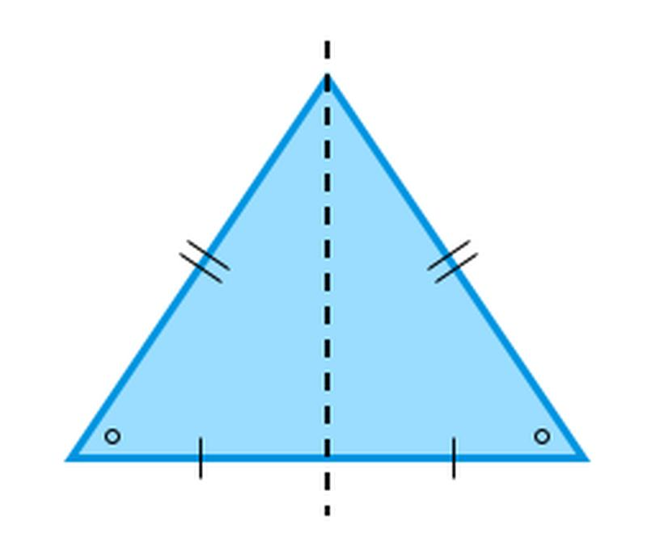
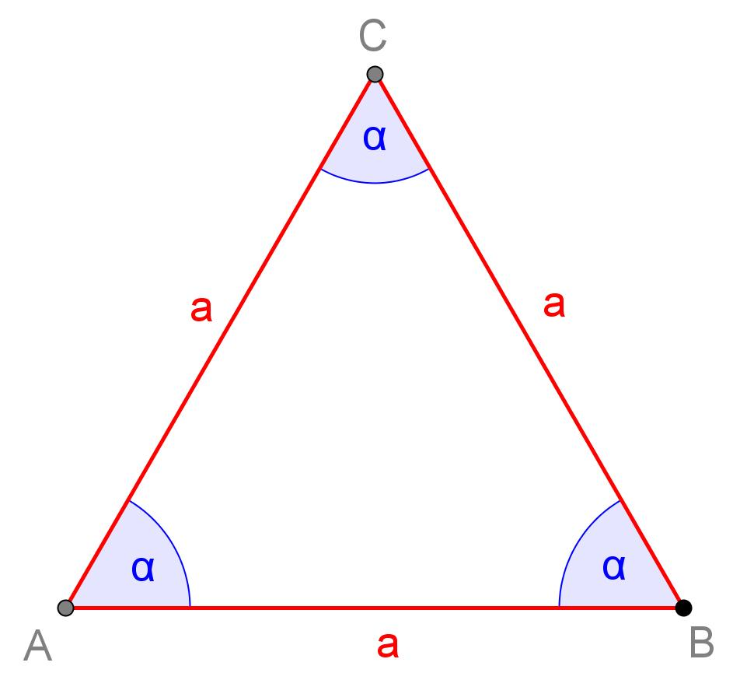
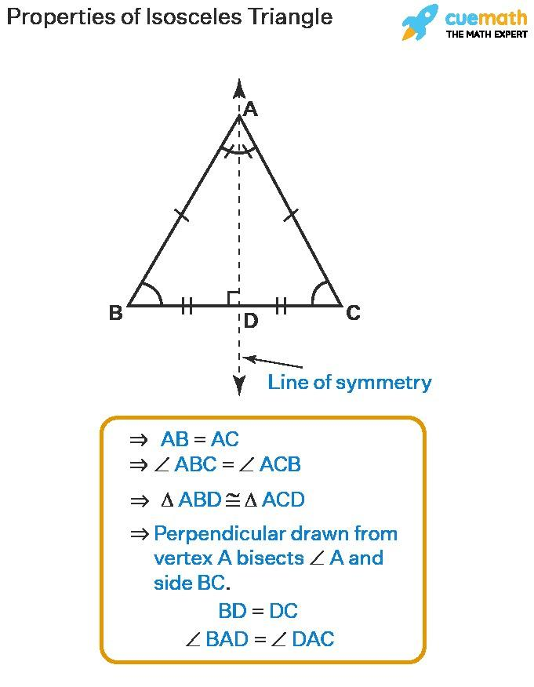
Symmetry can produce equal angles because symmetry transformations preserve angle measures.
Example
An isosceles triangle has a line of reflection symmetry.
The reflection maps one base angle onto the other:
$$\boxed{m∠B=m∠C}$$
Regular Polygon Example
A regular hexagon has six equal interior angles:
$$\boxed{m∠A=m∠B=m∠C=m∠D=m∠E=m∠F}$$
Each angle is:
$$\boxed{{120}^{∘}}$$

Equality from Transformations
# Source: AI Source: Provided by: [Data Path: Persons Table -> ID Column: 1, Name_En Column: Motasem Essam] -> From: [ChatGPT] on [7/25/2026]
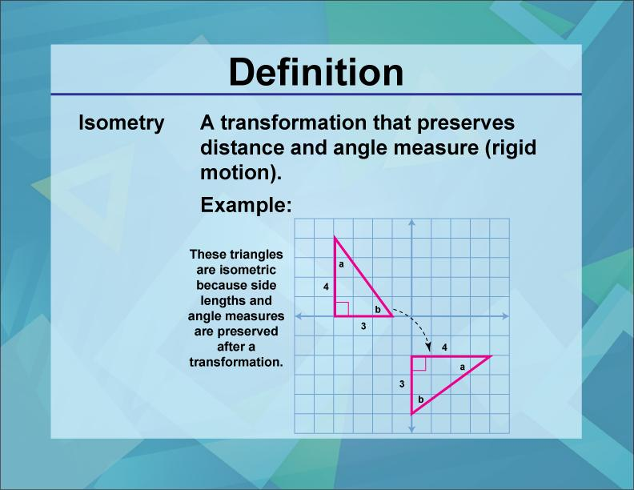
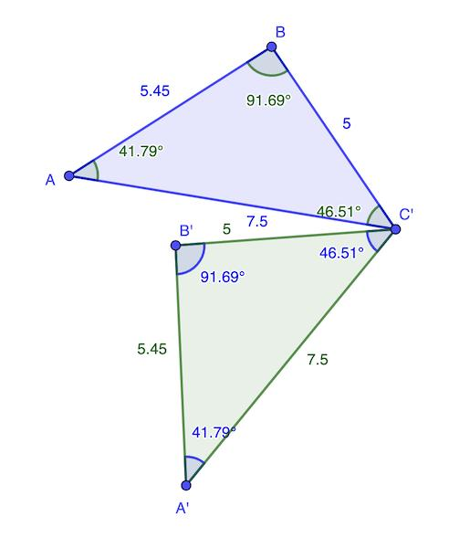
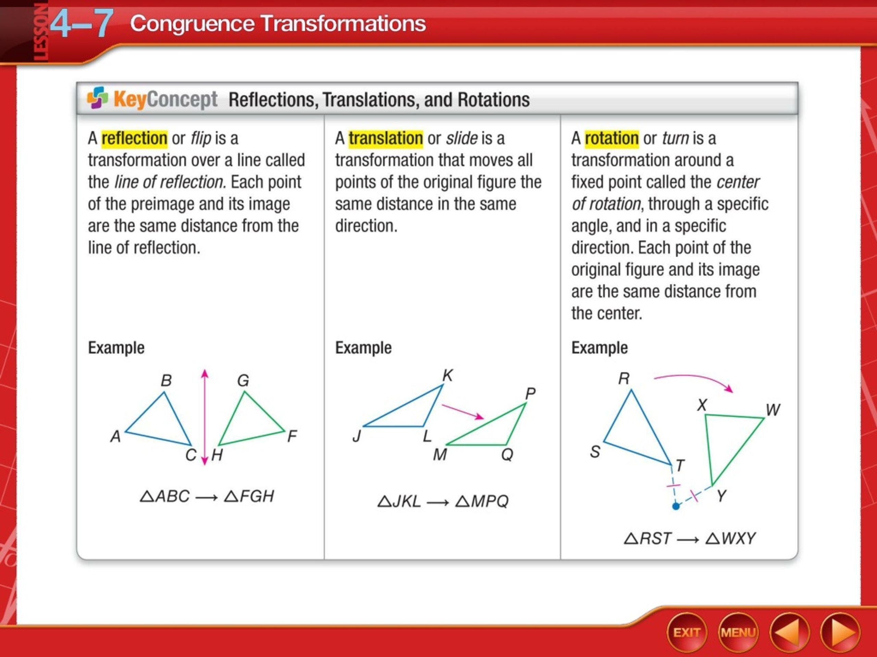
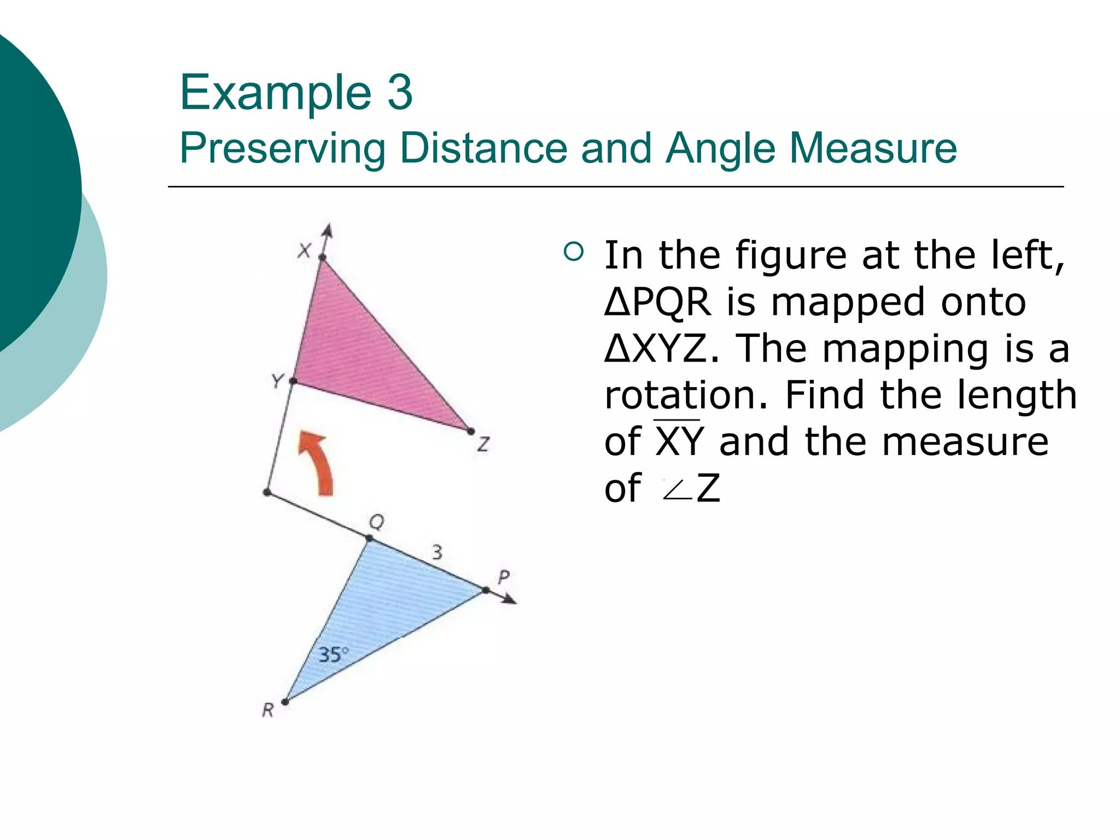
Certain transformations preserve angle measures.
These include the Euclidean isometries:
- Translation
- Rotation
- Reflection
- Glide reflection
If an angle is transformed into another angle:
$$∠A→∠A^{'}$$
then:
$$\boxed{m∠A=m∠A^{'}}$$
Example
If:
$$m∠A={75}^{∘}$$
and a reflection produces $∠A^{'}$, then:
$$\boxed{m∠A^{'}={75}^{∘}}$$

Equality from Circle Geometry
# Source: AI Source: Provided by: [Data Path: Persons Table -> ID Column: 1, Name_En Column: Motasem Essam] -> From: [ChatGPT] on [7/25/2026]
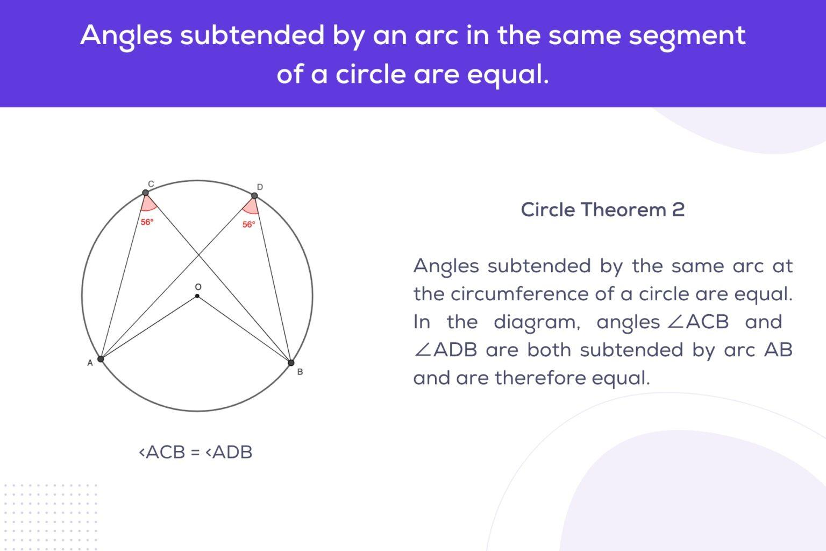
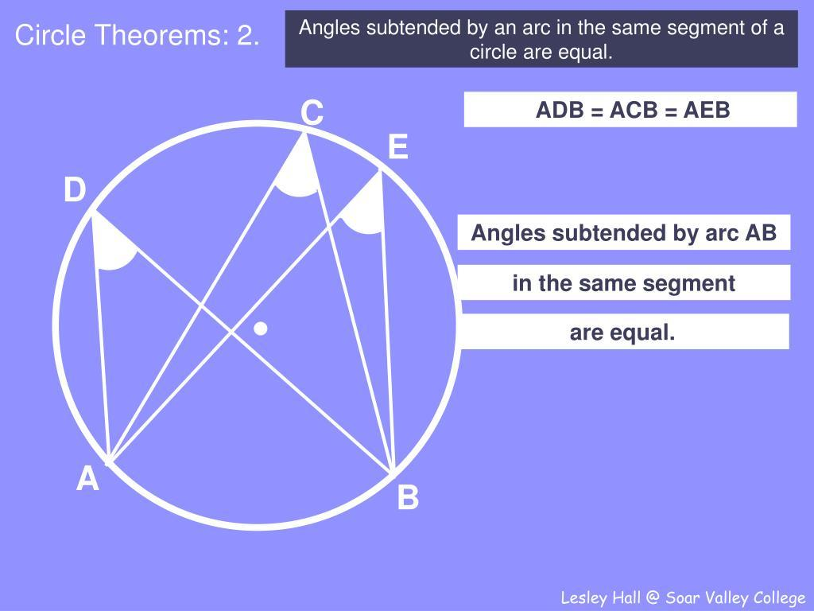
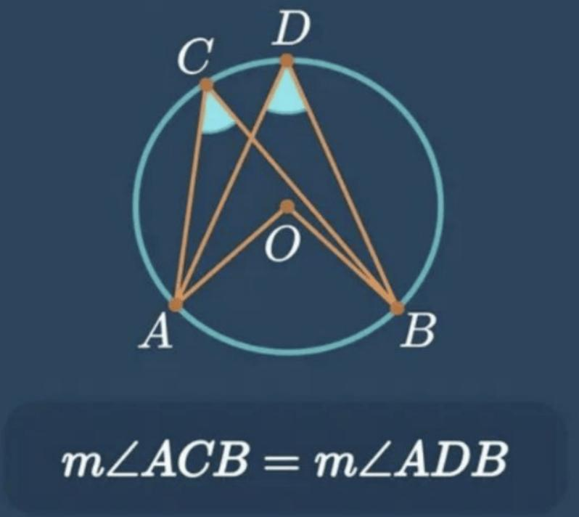
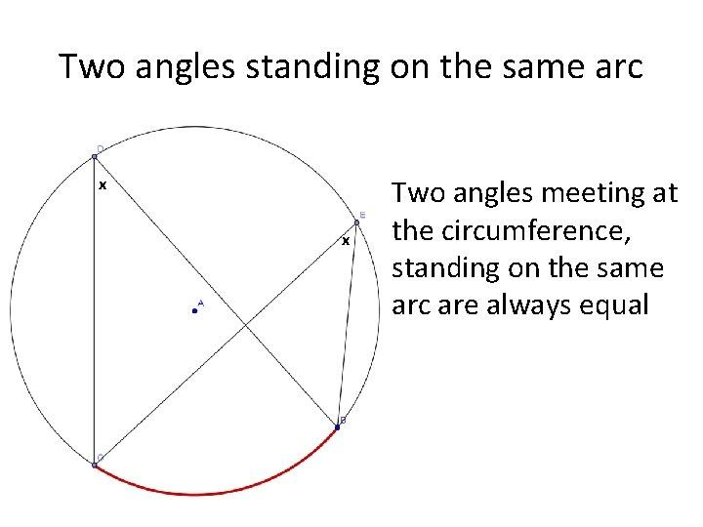
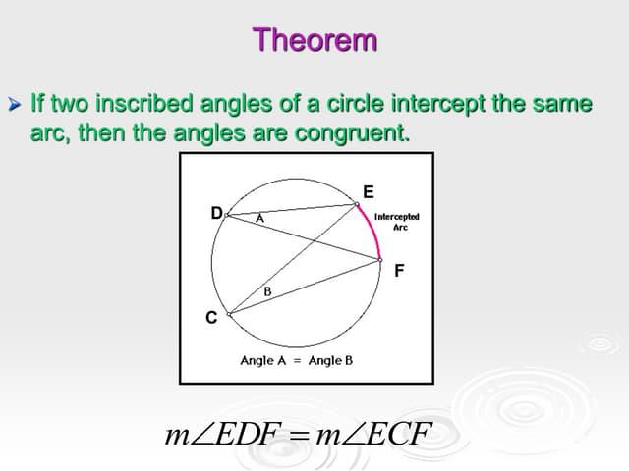
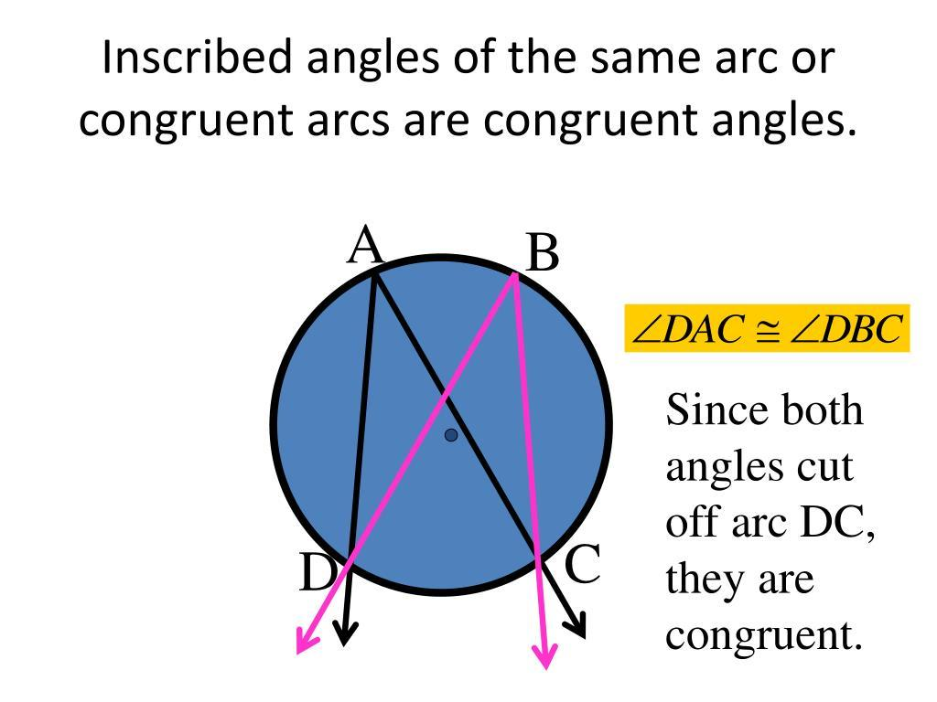
Circle geometry provides several important angle-equality relationships.
Same Arc
Inscribed angles intercepting the same arc are equal.
If $∠ACB$and $∠ADB$both intercept arc $AB$, then:
$$\boxed{m∠ACB=m∠ADB}$$
Example
If:
$$m∠ACB={40}^{∘}$$
then:
$$\boxed{m∠ADB={40}^{∘}}$$
Important Distinction
A central angle and an inscribed angle intercepting the same arc are not generally equal:
$$\boxed{m∠AOB=2m∠ACB}$$
So this is a relationship between their measures, not an angle equality.

Equality from Complementary Angles
# Source: AI Source: Provided by: [Data Path: Persons Table -> ID Column: 1, Name_En Column: Motasem Essam] -> From: [ChatGPT] on [7/25/2026]
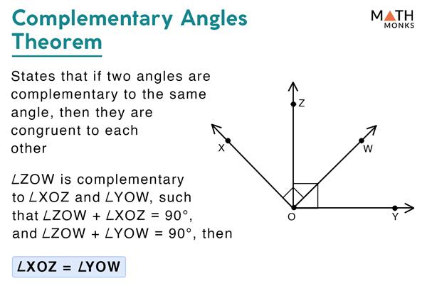
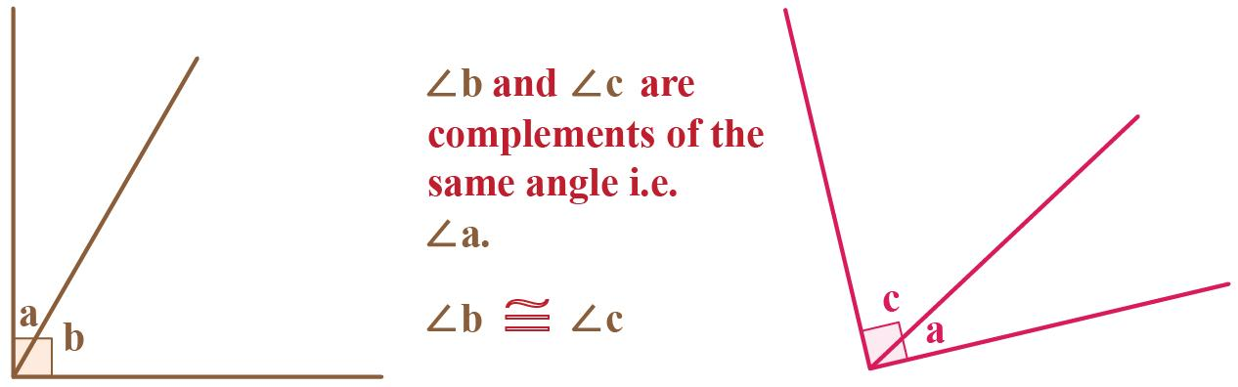
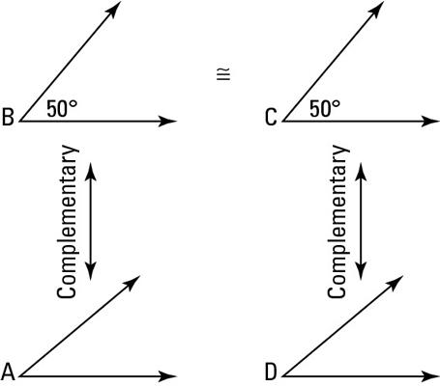
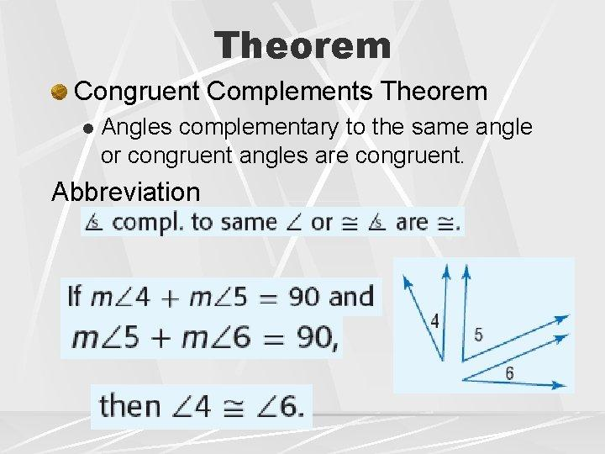
Two angles are complementary if:
$$m∠A+m∠B={90}^{∘}$$
If two angles are complementary to the same angle, they are equal.
Suppose:
$$A+C={90}^{∘}$$
and:
$$B+C={90}^{∘}$$
Then:
$$A={90}^{∘}-C$$
and:
$$B={90}^{∘}-C$$
Therefore:
$$\boxed{A=B}$$
This is the Congruent Complements Theorem.

Equality from Supplementary Angles
# Source: AI Source: Provided by: [Data Path: Persons Table -> ID Column: 1, Name_En Column: Motasem Essam] -> From: [ChatGPT] on [7/25/2026]
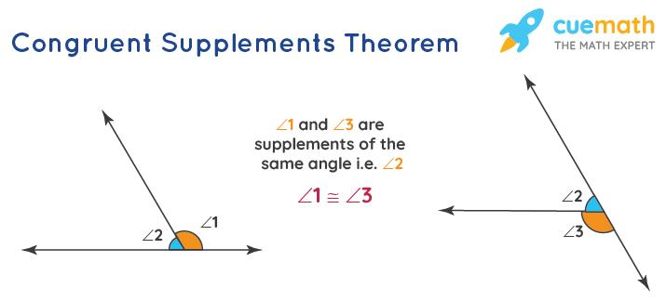
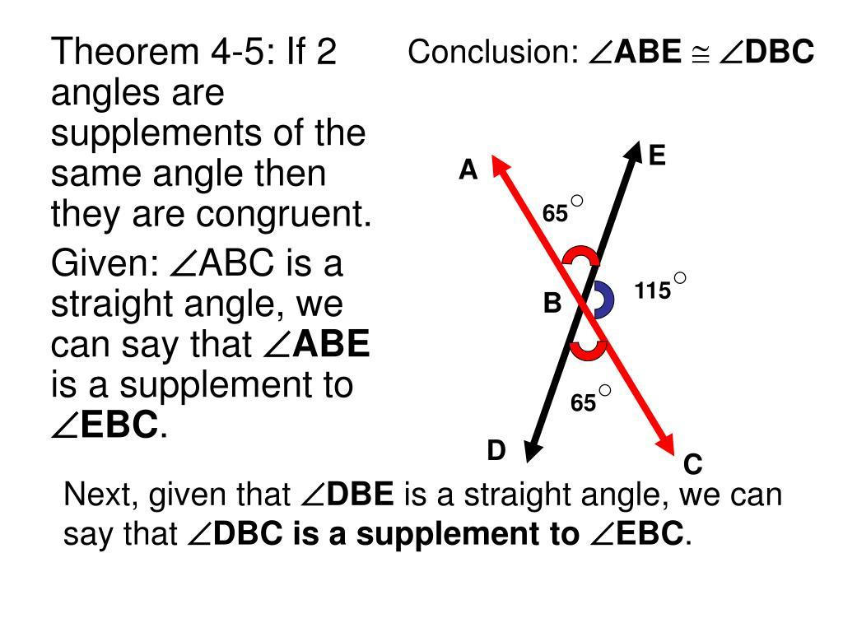
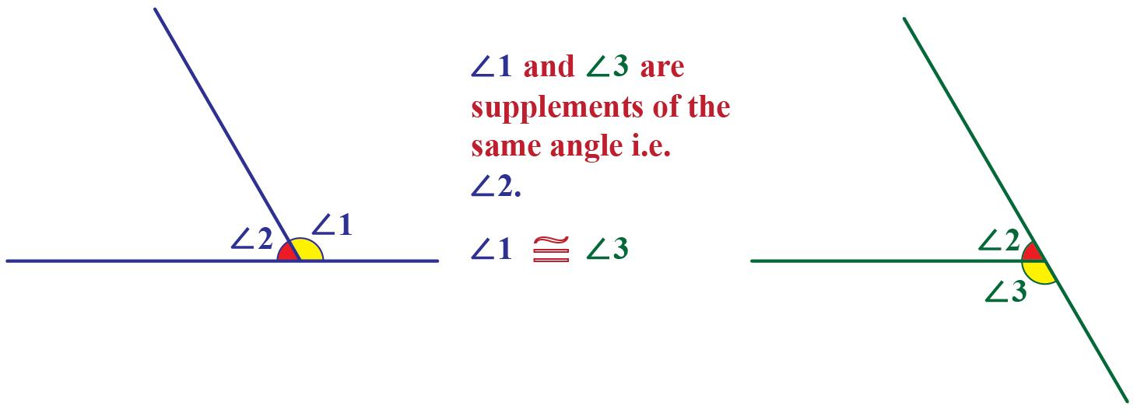
Two angles are supplementary if:
$$m∠A+m∠B={180}^{∘}$$
If two angles are supplementary to the same angle, they are equal.
Suppose:
$$A+C={180}^{∘}$$
and:
$$B+C={180}^{∘}$$
Then:
$$A={180}^{∘}-C$$
and:
$$B={180}^{∘}-C$$
Therefore:
$$\boxed{A=B}$$
This is the Congruent Supplements Theorem.

Equality from Algebraic Relationships
# Source: AI Source: Provided by: [Data Path: Persons Table -> ID Column: 1, Name_En Column: Motasem Essam] -> From: [ChatGPT] on [7/25/2026]
Angle equality can be established by solving equations.
Example
Suppose:
$$m∠A=3x+10$$
and:
$$m∠B=5x-20$$
If:
$$∠A=∠B$$
then:
$$3x+10=5x-20 \\ 30=2x \\ x=15$$
Therefore:
$$m∠A=3\left(15\right)+10={55}^{∘}$$
and:
$$m∠B=5\left(15\right)-20={55}^{∘}$$
Thus:
$$\boxed{m∠A=m∠B={55}^{∘}}$$

Equality from Coordinate Geometry
# Source: AI Source: Provided by: [Data Path: Persons Table -> ID Column: 1, Name_En Column: Motasem Essam] -> From: [ChatGPT] on [7/25/2026]
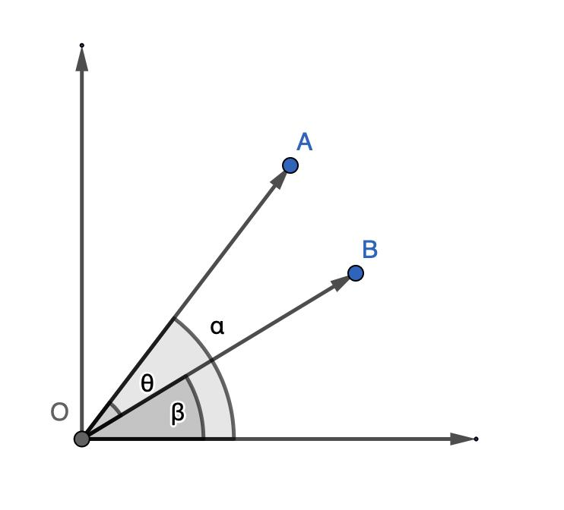
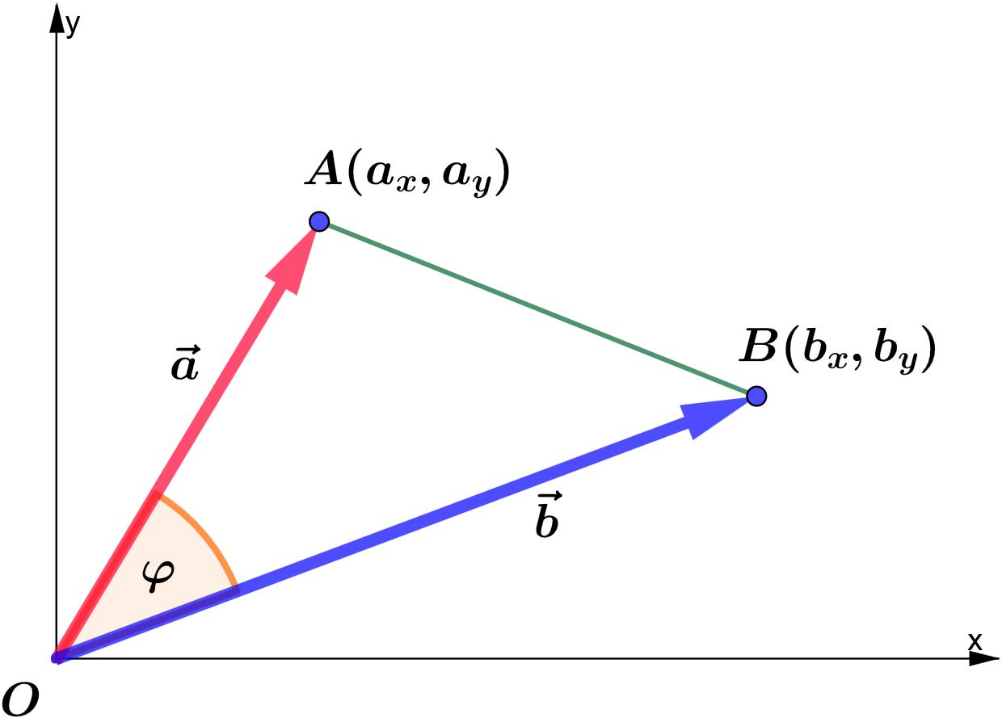
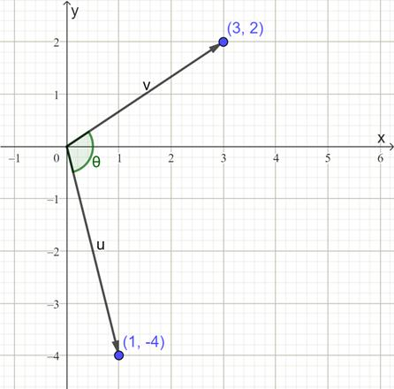
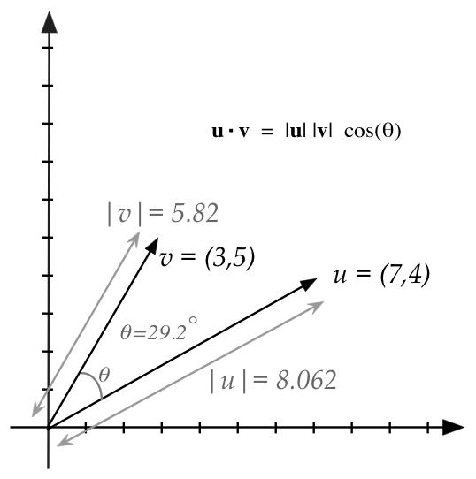
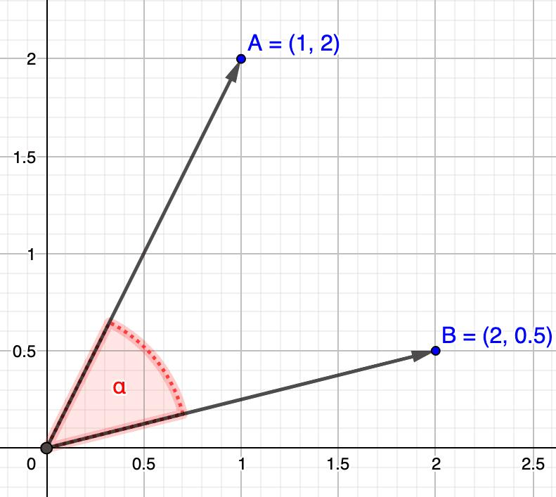
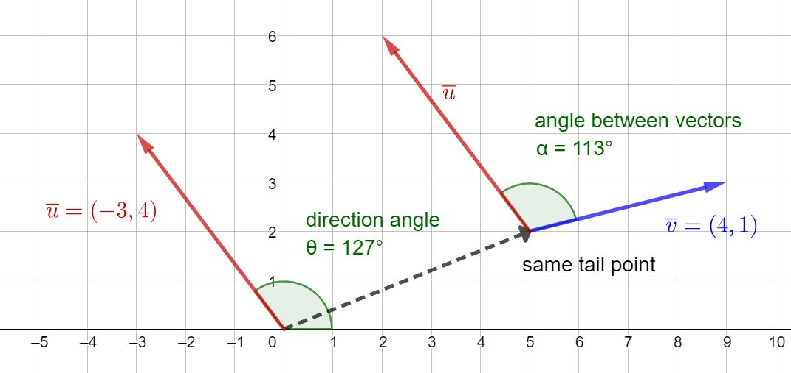
Angles can be compared using coordinates, vectors, slopes, or the dot product.
For vectors:
$$\vec{u}=\left(u_{1} , u_{2}\right)$$
and:
$$\vec{v}=\left(v_{1} , v_{2}\right)$$
the angle $θ$between them satisfies:
$$\boxed{\cos{θ}=\frac{\vec{u}⋅\vec{v}}{∣\vec{u}∣∣\vec{v}∣}}$$
If two angle calculations give the same angle, then:
$$\boxed{θ_{1}=θ_{2}}$$
Example
If two configurations both produce:
$$\cos{θ}=\frac{1}{2}$$
for angles between $0^{∘}$and ${180}^{∘}$, then:
$$\boxed{θ_{1}=θ_{2}={60}^{∘}}$$

Equality of Multiple Angles
# Source: AI Source: Provided by: [Data Path: Persons Table -> ID Column: 1, Name_En Column: Motasem Essam] -> From: [ChatGPT] on [7/25/2026]
More than two angles can be equal.
Equilateral Triangle
$$\boxed{A=B=C={60}^{∘}}$$
Regular Hexagon
$$\boxed{A=B=C=D=E=F={120}^{∘}}$$
Regular $n$-gon
Every interior angle has measure:
$$\boxed{\frac{\left(n-2\right){180}^{∘}}{n}}$$
Therefore, all interior angles are equal:
$$\boxed{A_{1}=A_{2}=⋯=A_{n}}$$

Angle Equality in Geometric Proofs
# Source: AI Source: Provided by: [Data Path: Persons Table -> ID Column: 1, Name_En Column: Motasem Essam] -> From: [ChatGPT] on [7/25/2026]
Angle equality is frequently used as a statement in geometric proofs.
Example
Given:
$$AB=AC$$
Prove:
$$∠B=∠C$$
Reasoning:
$$AB=AC \\ ⇓ \\ △ABC\text{ is isosceles} \\ ⇓ \\ \text{Base angles are equal} \\ ⇓ \\ \boxed{∠B=∠C}$$
That equality can then be used to prove another geometric relationship.

Important Angle-Equality Theorems
# Source: AI Source: Provided by: [Data Path: Persons Table -> ID Column: 1, Name_En Column: Motasem Essam] -> From: [ChatGPT] on [7/25/2026]
The most common sources include:
$$\boxed{\text{Vertical Angles Theorem}} \\ \boxed{\text{Angle Bisector Definition}} \\ \boxed{\text{Isosceles Triangle Theorem}} \\ \boxed{\text{CPCTC}} \\ \boxed{\text{Corresponding Angles Theorem}} \\ \boxed{\text{Alternate Interior Angles Theorem}} \\ \boxed{\text{Alternate Exterior Angles Theorem}} \\ \boxed{\text{Congruent Complements Theorem}} \\ \boxed{\text{Congruent Supplements Theorem}} \\ \boxed{\text{Same-Arc Inscribed Angle Relationship}}$$

Angle Equality vs Other Angle Relationships
# Source: AI Source: Provided by: [Data Path: Persons Table -> ID Column: 1, Name_En Column: Motasem Essam] -> From: [ChatGPT] on [7/25/2026]
Relationship | Meaning
$$m∠A=m∠B$$ | Equal measures
$$∠A≅∠B$$ | Congruent angles
$$A+B={90}^{∘}$$ | Complementary
$$A+B={180}^{∘}$$ | Supplementary
$$A>B$$ | $A$is larger
$$A<B$$ | $A$is smaller
$$A=2B$$ | $A$is twice $B$
For angles:
$$\boxed{∠A≅∠B ⟺ m∠A=m∠B}$$
But:
$$\boxed{\text{Complementary}≠\text{Equal}}$$
and:
$$\boxed{\text{Supplementary}≠\text{Equal}}$$
unless additional information establishes equality.

Main Classification Summary
# Source: AI Source: Provided by: [Data Path: Persons Table -> ID Column: 1, Name_En Column: Motasem Essam] -> From: [ChatGPT] on [7/25/2026]
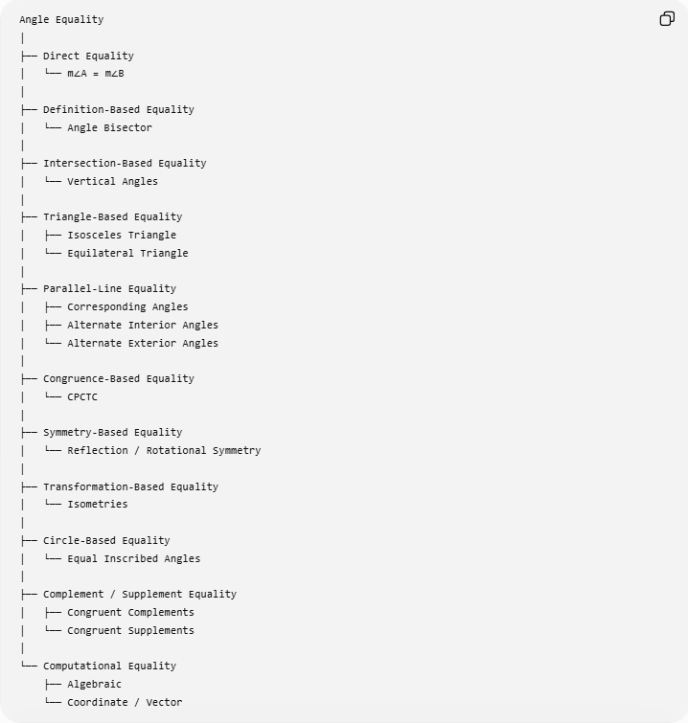
Angle Equality
│
├── Direct Equality
│ └── m∠A = m∠B
│
├── Definition-Based Equality
│ └── Angle Bisector
│
├── Intersection-Based Equality
│ └── Vertical Angles
│
├── Triangle-Based Equality
│ ├── Isosceles Triangle
│ └── Equilateral Triangle
│
├── Parallel-Line Equality
│ ├── Corresponding Angles
│ ├── Alternate Interior Angles
│ └── Alternate Exterior Angles
│
├── Congruence-Based Equality
│ └── CPCTC
│
├── Symmetry-Based Equality
│ └── Reflection / Rotational Symmetry
│
├── Transformation-Based Equality
│ └── Isometries
│
├── Circle-Based Equality
│ └── Equal Inscribed Angles
│
├── Complement / Supplement Equality
│ ├── Congruent Complements
│ └── Congruent Supplements
│
└── Computational Equality
├── Algebraic
└── Coordinate / Vector

Key Formulas
# Source: AI Source: Provided by: [Data Path: Persons Table -> ID Column: 1, Name_En Column: Motasem Essam] -> From: [ChatGPT] on [7/25/2026]
Angle Bisector
$$\boxed{m∠ABD=m∠DBC}$$
Vertical Angles
$$\boxed{m∠AOC=m∠BOD}$$
Isosceles Triangle
$$\boxed{AB=AC⇒m∠B=m∠C}$$
Equilateral Triangle
$$\boxed{m∠A=m∠B=m∠C={60}^{∘}}$$
Congruent Triangles
$$\boxed{△ABC≅△DEF⇒∠A=∠D, ∠B=∠E, ∠C=∠F}$$
Congruent Complements
$$\boxed{A+C={90}^{∘}, B+C={90}^{∘}⇒A=B}$$
Congruent Supplements
$$\boxed{A+C={180}^{∘}, B+C={180}^{∘}⇒A=B}$$
Same-Arc Inscribed Angles
$$\boxed{∠ACB=∠ADB}$$
when both angles intercept the same arc $AB$.

Relationship to Geometric Equality
# Source: AI Source: Provided by: [Data Path: Persons Table -> ID Column: 1, Name_En Column: Motasem Essam] -> From: [ChatGPT] on [7/25/2026]
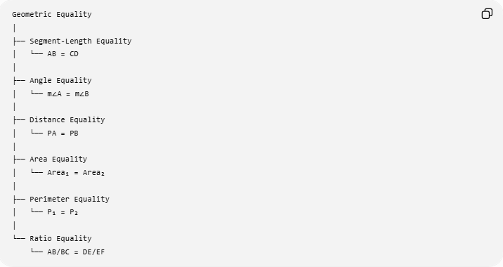
Geometric Equality
│
├── Segment-Length Equality
│ └── AB = CD
│
├── Angle Equality
│ └── m∠A = m∠B
│
├── Distance Equality
│ └── PA = PB
│
├── Area Equality
│ └── Area₁ = Area₂
│
├── Perimeter Equality
│ └── P₁ = P₂
│
└── Ratio Equality
└── AB/BC = DE/EF
Thus:
$$\boxed{\text{Angle Equality is a type of Geometric Equality}}$$
while Segment-Length Equality compares lengths:
$$AB=CD$$
and Angle Equality compares angle measures:
$$m∠A=m∠B.$$

Key Points
# Source: AI Source: Provided by: [Data Path: Persons Table -> ID Column: 1, Name_En Column: Motasem Essam] -> From: [ChatGPT] on [7/25/2026]
- Angle Equality means two or more angles have exactly the same measure.
- Its fundamental form is:
$$\boxed{m∠A=m∠B}$$
- Congruent angles have equal measures.
- Angle bisectors create equal angles.
- Vertical angles are equal.
- Corresponding, alternate interior, and alternate exterior angles are equal when the relevant lines are parallel.
- Isosceles triangles have equal base angles.
- Equilateral triangles have three equal ${60}^{∘}$angles.
- Congruent figures have equal corresponding angles.
- Isometries preserve angle measures.
- Inscribed angles intercepting the same arc are equal.
- Angles complementary to the same angle are equal.
- Angles supplementary to the same angle are equal.
- Algebraic, coordinate, and vector methods can establish angle equality.
- Angle equality compares measures, not the physical location or orientation of angles.

Conclusion
# Source: AI Source: Provided by: [Data Path: Persons Table -> ID Column: 1, Name_En Column: Motasem Essam] -> From: [ChatGPT] on [7/25/2026]
Angle Equality is the exact equality of two or more angle measures. It is one of the fundamental types of Geometric Equality and can be established through definitions, angle relationships, triangles, parallel lines, congruence, symmetry, transformations, circle geometry, algebra, and coordinate methods. It plays a central role in geometric proofs because equal angles often provide the connection needed to establish congruence, similarity, parallelism, symmetry, and other geometric properties.

